CMS User Manual

**Version 3.3.3**

PSL TEAM

5/4/2012

Contents

1 Header Section 5

1.1 Header Features 5

1.1.1 CMS Header Contents 5

1.1.2 CMS Header Menus 5

2 Catalog & 2D Plot 19

2.1 2D Plot Features 19

2.1.1 System checkbox 19

2.1.2 Upload 19

2.1.3 Catalog 19

2.1.4 Catalog Type 20

2.1.5 Scale 20

2.1.6 Apply 21

2.1.7 Catalog Details 21

2.1.8 Add 21

2.1.9 Tracking Object & Antenna Position Display 24

3 Polar Plot 25

3.1 Features 25

3.2 Viewing Polar Plot 25

3.2.1 Zoom-in and zoom out feature 27

4 Tracking Status 28

4.1 Tracking UI 28

5 Tune Receiver 30

5.1 Tune Receiver UI 30

5.1.1 Tools Menu 30

5.1.2 Settings and Command Execution 31

5.1.3 Configuration Parameters 32

5.2 Receiver Status 34

6 Batch Mode 35

6.1 Features 35

7 Manual Mode 39

7.1 Manual Mode Command Details 39

7.2 Data Acquisition Command Details 45

7.3 Command Execution Status 46

8 Data Monitor Tab 47

8.1 Data Monitor Tab Sections 47

8.1.1 Chart Recorder 47

8.1.2 Spectral Line Display 55

8.1.3 Pulsar Line Display 59

9 Expert Tab 65

9.1 Expert Tab Features 65

9.1.1 Select Subsystem Dropdown 65

9.1.2 CMD Execution Section 65

9.1.3 CMD Status Section 67

10 Command Log 69

10.1 Command Log Details 69

11 Meta Data 71

11.1 Meta Data Details 71

12 Engineering UI 72

12.1 Engineering UI Sections 72

12.1.1 Status Parameters: 72

12.1.2 Raw Parameters 72

12.1.3 Monitoring Parameters: 72

12.1.4 Basic Commands: 73

12.1.5 Detailed Commands: 74

12.1.6 Trend Plot: 74

13 State Machine 81

13.1 Start up and Initialization in State Machine 81

13.1.1 State Machine start-up 81

13.1.2 State Machine initialization 82

13.1.3 State Machine initialization on power failure 84

13.2 Viewing the alarms 86

13.3 Clearing and acknowledging the alarms 87

13.3.1 Alarm clearing 87

13.3.2 Alarm Acknowledging 90

13.4 Enabling-Disabling of Alarms 91

13.4.1 Disabling of Alarm 91

13.5 Changing state in CMS 94

13.6 Dashboard Status Message and Timestamp 96

13.7 Monitoring Parameter out of range Alarms 96

14 Miscellaneous 98

14.1 Pre-Observer Role 98

14.2 Active Controller 98

14.3 Message Console Logs 100

14.4 Dashboard logs 100

14.5 Email Alerts 100

14.5.1 User Registration 100

14.5.2 Critical Alarm Alert 100

# Header Section

## Header Features

### CMS Header Contents

1. Change Password: This link allows logged in user to change their password
2. Welcome Text: Shows the welcome text for user with Username of the logged user

And Role of logged in user

1. Sign Out: Allows logged in user log out of the system
2. Date :Current Calendar Date
3. LST: Shows current Local sidereal Time
4. UTC: Shows the UTC corresponding to current IST time
5. IST: Shows current date in Indian Standard date
6. Usage Mode (SINGLE/MULTIPLE): Indicates whether CMS is used in single user mode or multi user mode. This setting can be changed from “Settings->CMS Settings” link
7. Project – Displays the project code for current active observation
8. Set up : Displays either of following values along with corresponding band center frequency
   1. Continuum
   2. Pulsar
   3. Spectral
   4. Sun-moon
   5. planetory
9. CMS State: Current CMS state, this state is derived from state machine.
10. ANT STATE: Display current servo subsystem status.
11. Object ,RA,DEC :Current object tracked by telescope, and its corresponding RA,DEC
12. DATA ACQ: Display current data acquisition status.
13. ALARM: Recent Alarm generated by CMS by virtue of information received from wrapper or the alarm sent over directly by wrapper.
14. Active Controller: Shows name of astronomer who is currently actively using the antenna. Please refer to Active Controller section in miscellaneous section for further details.

### CMS Header Menus

#### Home

This menu link allows user to move to home page from any part of the application.

#### Dashboard

This menu link displays the CMS current state. It also allows user to change CMS from one state to another. It also displays current state of individual subsystem and alarms specific to particular subsystem.

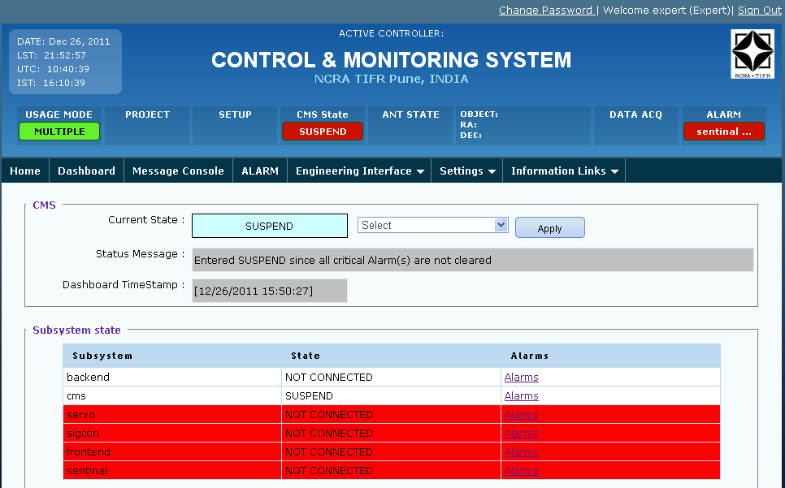

User can view alarms of particular subsystem by clicking on the Alarm hyperlink.

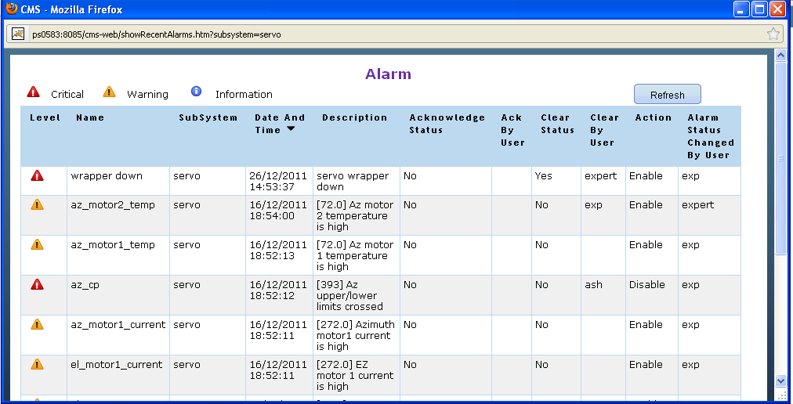

#### Message Console

Displays current command execution status .Latest command execution is displayed on top.

In case of motion commands, the percentage motion completed is also shown here. Wrapper needs to send a parameter named “steps” as part of intermediate response. This parameter should include the actual number of steps completed, so that CMS can calculate and display appropriate percentage motion completed.

All the entries in this console are also logged in separate log file messageconsole.log.

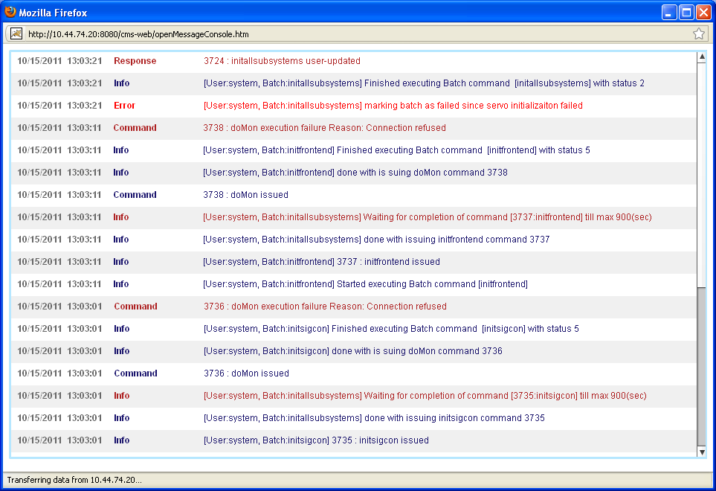

#### Alarm

Displays all generated alarm history. User can also sort the alarms based on various columns. User need to click on column header to sort that column. By default alarms are sorted by date and time.



#### Engineering Interface

This menu provides link individual subsystem engineering interface where engineer can monitor system parameters and carry out engineering activities. Please refer to engineering UI section of document for further detail. The Engineering Interface contains pull-down menu for accessing individual subsystem Engineering UI.

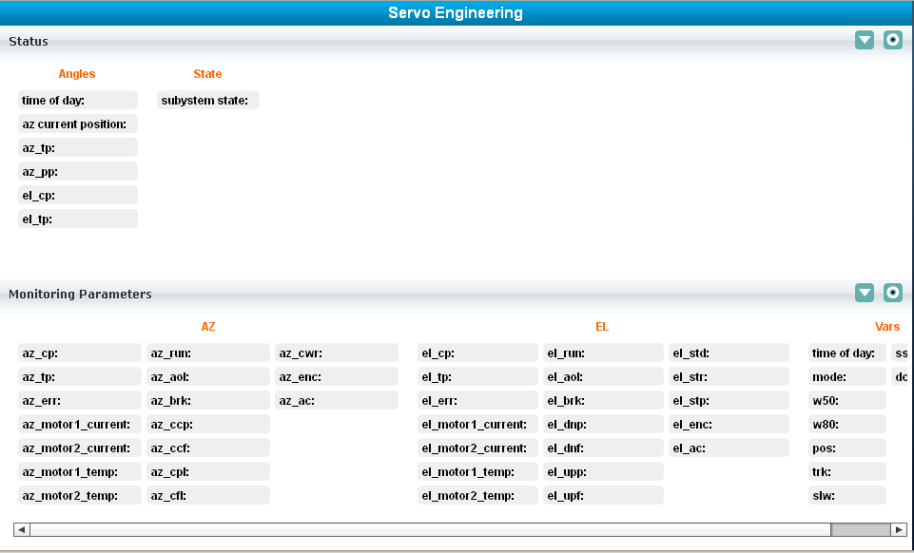

#### Settings 🡪 My Settings

Logged in User can update his contact details.

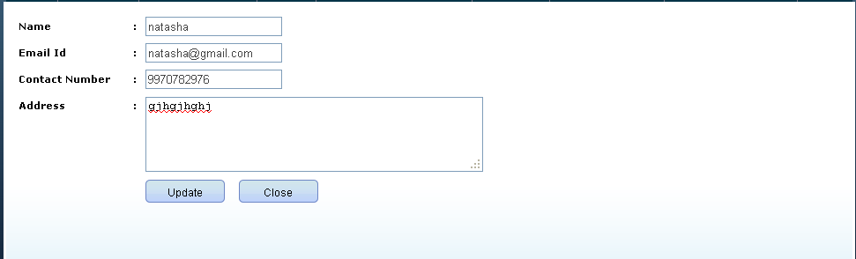

#### Settings 🡪 CMS Settings

Logged in user can change the usage mode to multiple/single, and mute the critical/non-critical alarms.

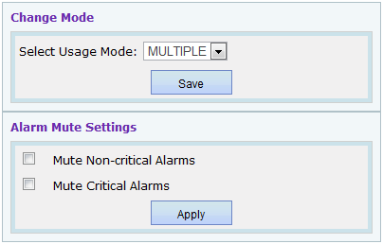

***Alarm Mute Settings***

Alarm Mute Settings will display the current mute/un-mute settings for critical/non-critical alarms.

When user checks “Mute Critical alarms” and clicks on Apply all the critical alarms raised will go to mute state.

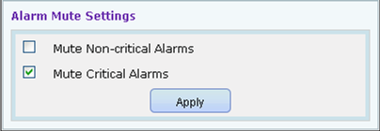

When user checks “Mute Non-critical alarms” and clicks on Apply all the non-critical alarms raised will go to mute state.

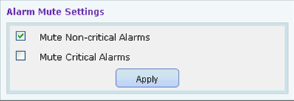

Similarly user can uncheck to un-mute critical/non-critical alarms.

#### Settings 🡪 Force Logout

Force Logout option is visible to user only if “**FORCE LOGOUT** “permission is assigned to the logged in user’s role through Role Management. This allows user to forcefully log out other logged in users. Only non-expert, non-admin users can be logged out using this feature.

Log out All 🡪Allows to log out all the logged in users except admin and expert users.

Refresh 🡪Allows to refresh the logged in users list.

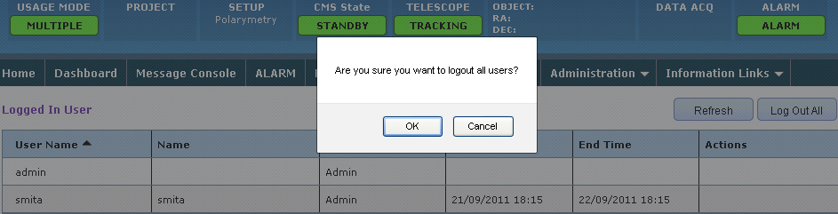

#### Administration 🡪User Management

This menu link displays all users and their details available in the system. It also displays their Active/Inactive status.

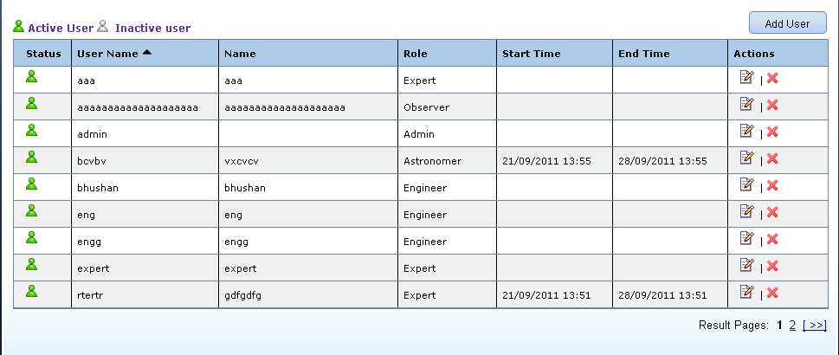

User can update information of a user by clicking on Edit button in Actions Column on right side.

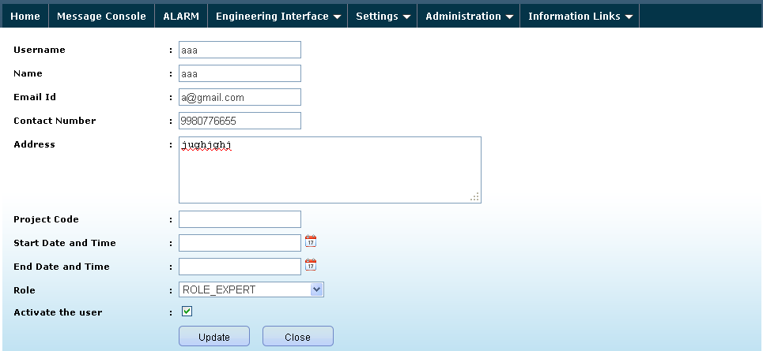

One can Deactivate user by clicking on the Deactivate button in Actions column.

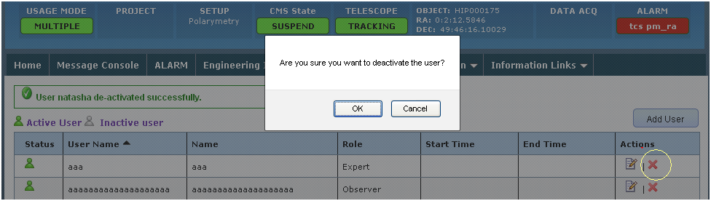

#### Administration 🡪User Management 🡪 Add User

This menu link allows user to add new users in the system. Fields marked in red are the compulsory fields. User can select the desired role to be given to the new user from Role dropdown.

If a role selected for user is “**ROLE_ASTRONOMER**” or “**ROLE_CO-ASTRONOMER**” then it is mandatory to specify Project code, start and end date time.

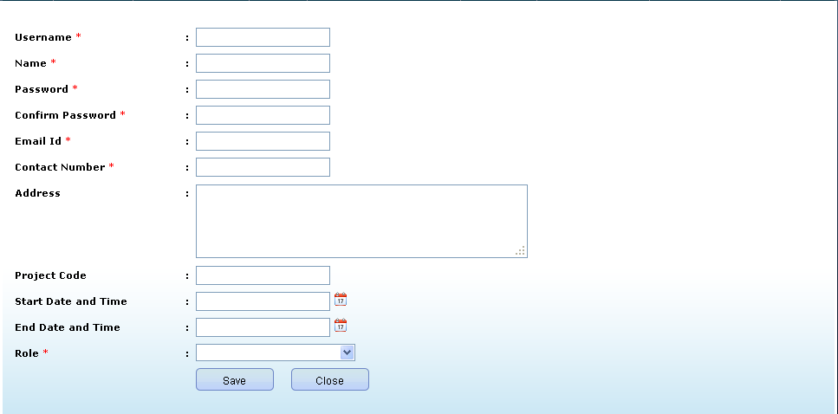

#### Administration 🡪 Role Management

User can view all the available roles in the system. One can also edit or delete a particular role. In case of deletion if any other user is assigned that role, the role will not be deleted.

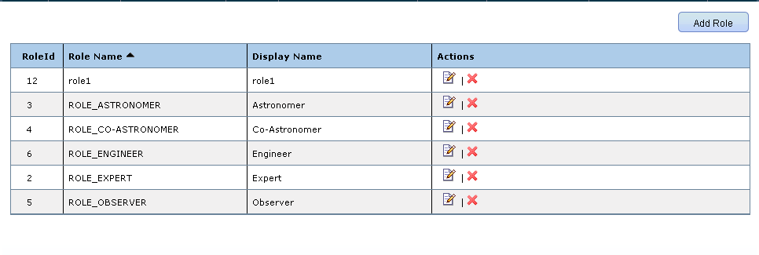

##### Add Role

This button enables user to add new role in the system.

**For Example**: Consider addition of new role as “**sample_role**” in the system.

User needs to enter the role name and display name.

User needs to select **Permissions** to be given to the new role by selecting permissions from the dropdown.

Description of available permissions:

1. **DEFAULT PERMISSIONS**: This is a minimum subset of generic set permissions .It contains permissions like allowing user to view and access home page, alarms, message console, Change password etc.

List of default permissions:

* BF_SHOW_HOME – Allow user to view home page of the CMS.
* BF_CONTROL_STATUS – Allow user to view header.
* BF_SHOW_ALARMS – Allow user to view the alarms.
* BF_ACK_ALARM – Allow user to acknowledge alarm.
* BF_GET_CMDLOG – Allow user to view command log.
* BF_CHANGE_PWD – Allow user to change password.
* BF_PLOT- Allow user to view 2D plot.
* BF_CATALOG – Allow user to view Catalog management.
* BF_SHOW_CMSINFO –Allow user to view the content of Help Menu
* BF_CREATE_EXCEL - Allow user to create excel sheet for command log.BF_OPEN_MSGCONSOLE – Allow user to view message console.
* BF_ABOUTUS – Allow user to view About Us page.
* BF_SHOW_TRACKINGSTATUS – Allow user to view Tracking status.BF_SHOW_RECEIVERSTATUS – Allow user to view Receiver status.
* BF_VIEW_DASHBOARD-Allow user to view Dashboard.

1. **USER MANAGEMENT**: User management is visible and accessible to user, only if this permission is given.
2. **EXPERT TAB**: Expert tab is visible and accessible to user, only if this permission is given.
3. **TUNE RECEIVER**: Tune receiver tab is visible and accessible to user, only if this permission is given.
4. **DISPLAY TAB**: Display tab is visible and accessible to user, only if this permission is given.
5. **MANUAL MODE**: Manual mode tab is visible and accessible to user, only if this permission is given.
6. **FORCE LOGOUT**: Force logout feature is visible and accessible to user, only if this permission is given. It allows user to forcefully logout other logged in users.
7. **BATCH MODE**: Batch mode tab is visible and accessible to user, only if this permission is given.
8. **COMMAND LOG**: Command log is visible and accessible to user, only if this permission is given.
9. **META DATA:** Meta Data is visible and accessible to user, only if this permission is given, by default admin and expert users can see the Meta Data tab.
10. **ROLE MANAGEMENT**: Role management feature is visible and accessible to user, only if this permission is given.
11. **DISPLAY_TAB_SAVESYSTEM_CATALOG:** Enables user to save catalog as system catalog.
12. **SERVO_ENGINEERING:** Servo engineering interface is visible and accessible to user only if this permission is given.
13. **CMS DASHBOARD**: CMS dashboard is visible and accessible to user, only if this permission is given.
14. **ENABLE DISABLE ALARM:** User can enable/disable alarm, only if this permission is given**.**
15. **CLEAR ALARM:** User can clear alarm,only if this permission is given.
16. **MAINTENANCE STATE:** If CMS is in maintenance state, user can log in to CMS only if this permission is given.
17. **CHANGE CMS STATE**: User can change CMS state from one to another, only if this permission is given.

Consider that user does not want “sample_role” to view the EXPERT TAB then keep “**EXPERT TAB**” option unselected. This will never allow users with “sample_role” role to view expert tab unless that permission is reassigned to that role.

Permissions assigned to user with “**Admin**” role cannot be changed.

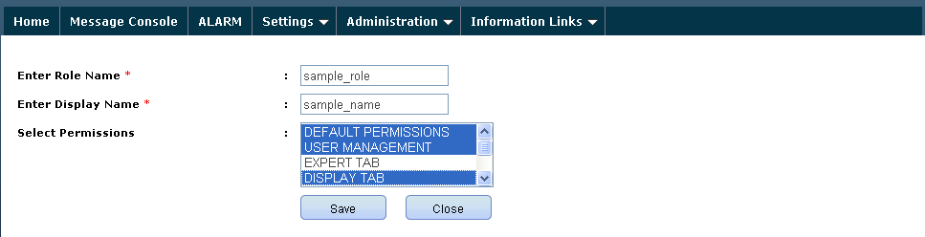

Role “sample_role” added successfully.

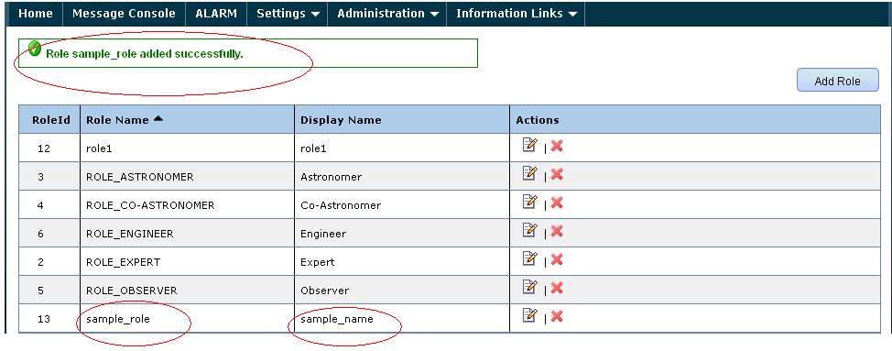

Consider now, we want users with “**sample_role**” to view Expert tab. In that case user needs to click on Edit button in Actions Column (See top right) against “sample_role”. Select “EXPERT TAB” from Permissions list and Click Update. ”**sample_role**” can now view Expert tab.

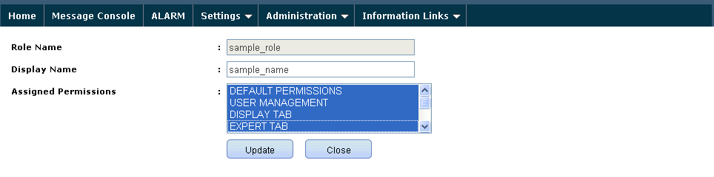

#### Information Links 🡪 Help Menu

Provides important help links. The link path can be changed by modifying the path in cmsinfo.properties file.

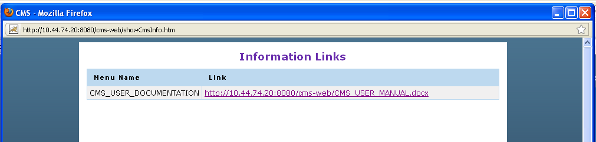

#### Information Links 🡪 Batch Templates

This link opens a page which displays the information related to the Batch Templates available. To download the batch template the user will have to click on the batch file name.

The Batch templates can be configured in BatchMenu.properties.

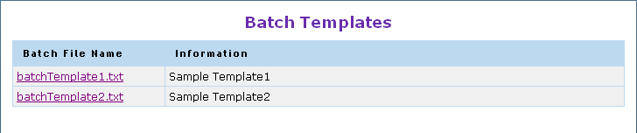

#### Information Links 🡪 Catalog Templates

This link opens a page which displays the information related to the Catalog Templates available. To download the Catalog template the user will have to click on the Catalog file name. The Catalog Templates can be configured CatalogMenu.properties.

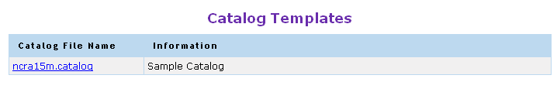

# Catalog & 2D Plot

This section allows the user to upload the catalogs into the system, edit or delete them. It facilitates addition of various sources from catalog into the 2D plot.

## 2D Plot Features

The 2D plot displays the selected catalog source objects plot as per their Dec value for the current RA value. 2D plot also displays the Galactic curve for reference as displayed below:

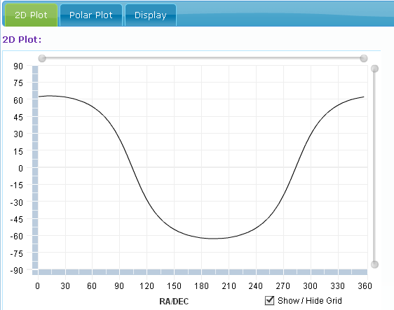

### System checkbox

It is visible to user who has corresponding permission (UPLOAD_SYSTEM_CATALOG), through this; user can upload the catalog which can be used across the system by all users.

### Upload

After selecting file in correct format user can upload the catalog into the system. Refer to system check box documentation (section 2.2.1 System check box) for understanding how to upload system wide catalogs.

### Catalog

This button allows user to view Catalog.

Go to “Catalog and Settings” tab in section 2 of Home page. Select the catalog database (either user or system) using the radio button. Click on “View Catalog” button to view the catalog.

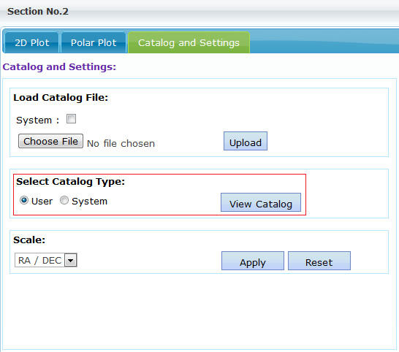

### Catalog Type

* User - Catalog specific to the logged in user are displayed.
* System- all System catalogs is displayed.

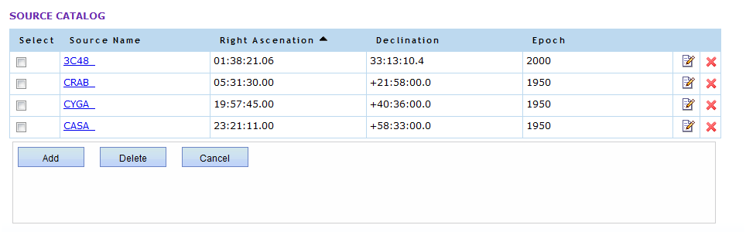

### Scale

If selected as Ra/Dec, the 2D plot is plotted with scale Ra vs. Dec.

User has also got an option to select Az/Alt for 2D plot display.

### Apply

After changing the scale (RA/DEC or ALT/AZ) user needs to click on ‘Apply’ button to apply the changes in 2D plot.

### Catalog Details

User comes to this page after clicking on ‘Catalog” button in Display tab in Section 2.

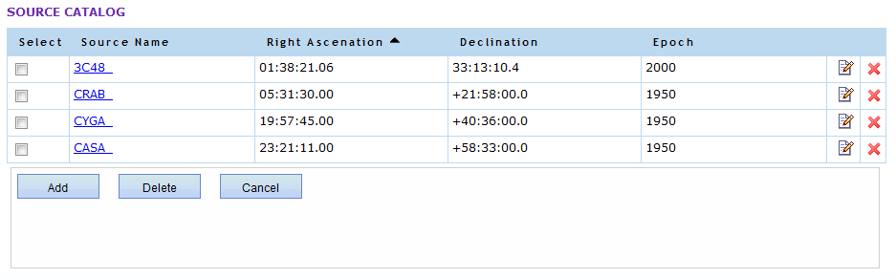

### Add

On clicking the catalog button the source list on the catalog details page will be displayed to user as shown below. User can select the source to be added to 2D plot from the list by selecting the checkbox of that source. Click on Add button to add the selected source to 2D plot.

The selection of already plotted object is disabled.

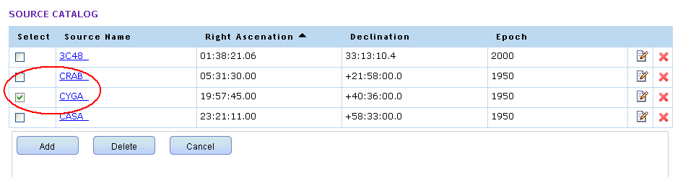

On clicking on Add the user will be asked to confirm the addition of object. If ok is selected the user will be taken to the 2D plot UI where the newly added object will be visible as displayed below:

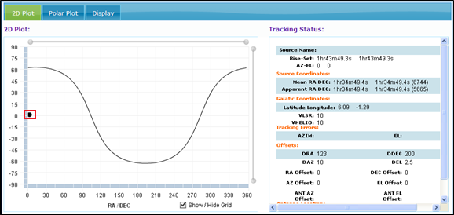

#### Delete

On Clicking Delete button the user will be asked to confirm the deletion of object. If ok is selected, the selected catalog will be deleted from the database.

#### Edit

User can also update the catalog details by clicking on the edit button as shown below.

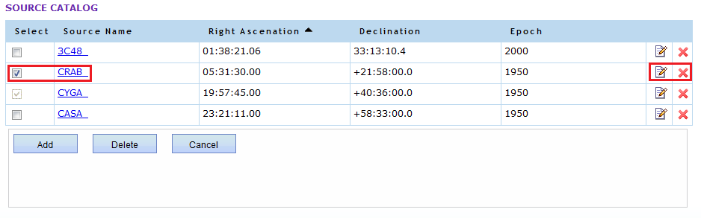

Edit button will open Edit Catalog page which will allow user to edit the selected catalog.

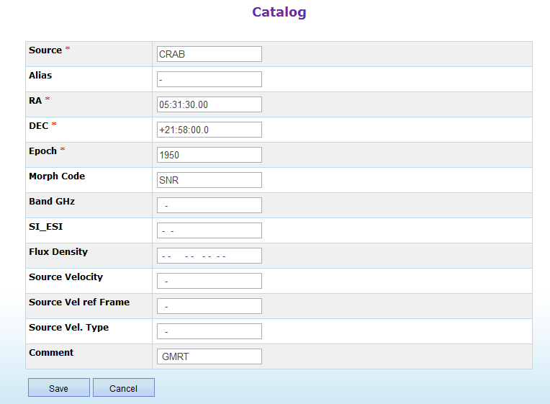

#### Remove from Plot

When user clicks on the delete button provided in extreme right against each catalog, the selected source object is deleted from the 2D plot.

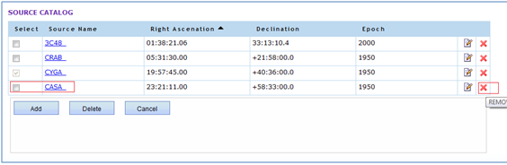

**Note**: Source Name containing value “ERROR” or “error” should be not used since it is being used as a keyword in CMS for communicating errors.

### Tracking Object & Antenna Position Display

#### Tracking Object Display:

Current object being tracked gets added in 2d plot when user executes the trackobject command from the expert tab, or issues track command from manual mode. After execution of the trackobject command, the target source can be seen in blue color.

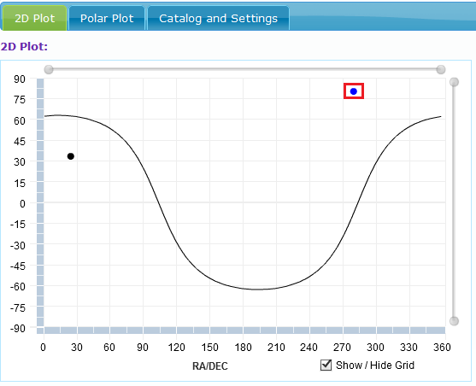

#### Antenna Position Display:

The antenna position in 2d plot can be viewed when, CMS receives the “ant_ra” and “ant_dec” monitoring parameters values from wrapper, and here antenna position can be seen in orange color.

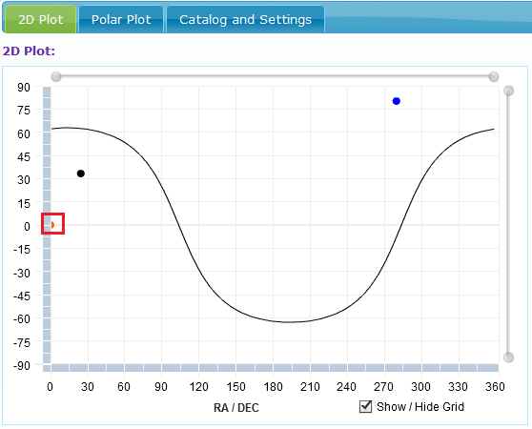

# Polar Plot

Polar plot displays the tracking of actual position of Telescope and the position of the source being tracked (target position).

## Features

1. Zoom-in and zoom out
2. Configurable telescope position points
3. Configurable refresh interval for updating polar plot

## Viewing Polar Plot

To view polar plot go to **Section 2** 🡪 **Polar Plot tab**

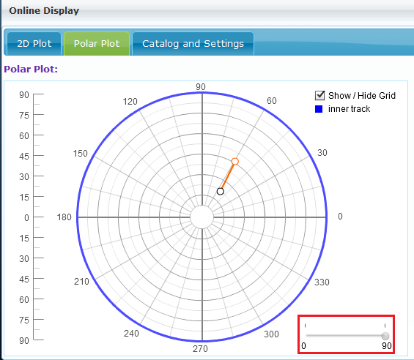

Here orange color showing az, el tracking points, Red marker indicates zoom- in zoom-out functionality, blue track color indicated the inner track, black color showing the starting point of az, el tracking points.

**Tracking Object Display:**

The tracking object in polar plot gets added when user executes the trackobject command from the expert tab. After execution of the trackobject command the target source can be seen in blue color, here in above figure it is in center.

**Inner/Outer Track Display:**

The Inner track is displayed if the srvcrd global property value is 0. This is the default track. For outer track the srvcrd value can be changed to 1. This value can be changed by executing the command “load property, srvcrd, 1“ from the expert tab (under cms subsystem). The outer track is displayed in the figure below.

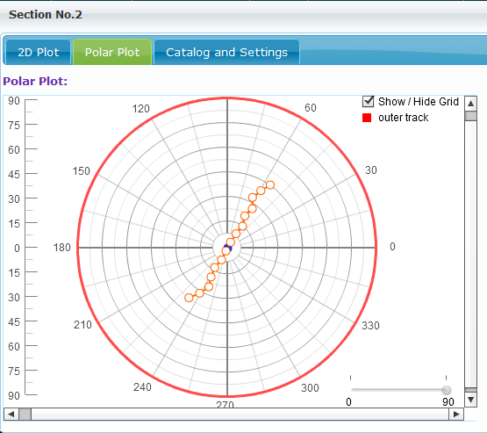

Target source is in blue color.

### Zoom-in and zoom out feature

Polar plot has capability to zooms in and zooms out elevation, from scale 0-90, default it is in 90, e.g. here we can zoom in to 45 as show in below figure.

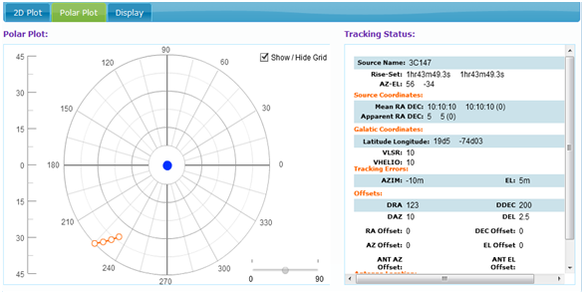

# Tracking Status

Tracking status section shows the status of Antenna Tracking parameters.

1. .

## Tracking UI

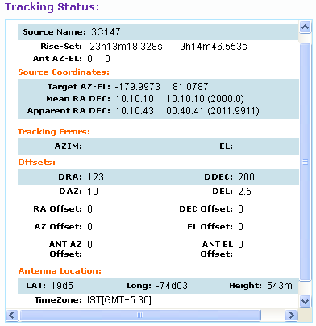

It shows the information about the source which is being tracked actively. As shown in the figure, the information about the source ‘CYGA’ is getting displayed. It shows the Mean RA, Mean DEC, Epoch, Apparent RA, Apparent DEC and Epoch, Azimuth Elevation etc. related Information about the source.

The Source Name, Rise-Set and other source related parameters get updated when servo trackobject command is executed. The Az-El gets updated when az_cp and el_cp servo monitoring parameters are received by CMS.

The Tracking status gets updated in the following scenarios:

1. TrackObject or rawtrack command is executed from Expert tab.
2. Track is executed from manual mode
3. loadProperty command is executed from Expert tab for any of the Tracking Status parameters.
4. Ldantoff command from servo updates the ANT Az Offset and ANT El Offset from tracking status.
5. The ANT az – el gets updated when az_cp and el_cp servo monitoring parameters are received by CMS.
6. Tune Receiver Digital backend settings when applied will update the Tracking Status as per settings selected by user.

# Tune Receiver

This section is used to tune settings of various subsystems (sigcon, frontend, digital backend) before observation starts.

## Tune Receiver UI

### Tools Menu



#### OBS SETUP

This is used to choose one of the following 5 standard receiver setups.

Each of these setups have a receiver setup file associated with it, same is mentioned in braces below

* Continuum (continuum.xml)
* Pulsar(pulsar.xml)
* Spectral(spectral-line.xml)
* Planetory(planetory.xml)
* Sun-moon(sun-moon.xml)

When user selects one of the setup Tune receiver UI is loaded with settings for corresponding observational setup.

User may also customize the values as per the observational needs.

#### Clear

Used to reset/reload various defaults settings associated with standard receiver setups.

#### Load

This is used to import the tune receiver settings from custom/standard receiver setup files.

Tune receiver settings can be customized at 2 levels

* Customizing the values for parameters - This involves modifying the values for standard configuration parameters and then exporting them to xml file using Save functionality described in section 5.2.1.4
* Customizing the Parameters – This involves adding or removing the configuration parameters for some of the subsystem. Please refer to Tune Receiver section in “Dynamic UI Generation.docx” for further details.

The custom files are used to tune the subsystems if observational needs fall outside the standard range of observation parameters.

#### Save

It exports the contents of Tune Receiver settings to create custom receiver settings for use at later point of time using Load functionality mentioned in section 5.2.1.3

### Settings and Command Execution

This section allows user to first customize the settings for a given setup and then send configuration commands to wrapper. User can also save these settings using Save functionality mentioned in section 5.2.1.4



#### Default

Used to reset/reload various defaults settings associated with selected receiver setup.

All the controls for configuration parameters are disabled when user selects this option forcing user to send standard configuration parameters to wrapper.

#### Custom

In case user needs to modify the default configuration settings, this option should be selected. It enables the controls so that user can modify the parameters send customized values to wrapper.

#### Set

This control allows user to select a specific subsystem for which command configuration is to be done. It also allows to do command configuration for all subsystems at once if user selects “all” option. In order to send configuration information to wrapper user should click on “Apply” button.

### Configuration Parameters

This section shows various configuration parameters for all three subsystems. For digital back end sub system these parameters are also stored at global level in CMS so that other subsequent digital backend commands can use these configuration settings.

User can add or remove parameters in any of section as described in “Dynamic UI Generation.doc” document.

#### Configuration parameters for Frontend

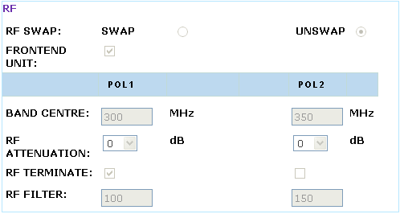

#### Configuration parameters for Sigcon

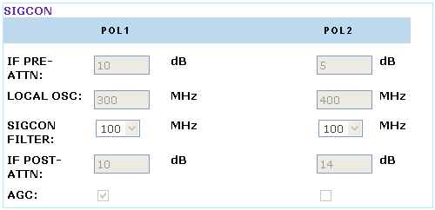

#### Configuration parameters for Digital Backend

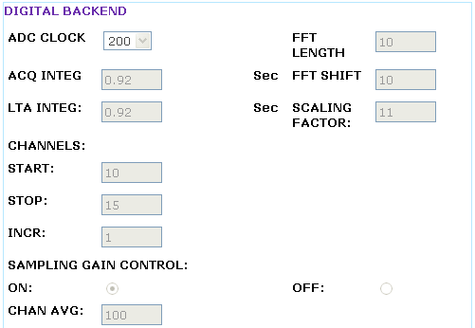

Note – Only few parameters for digital backend are shown here because of space constraints.

## Receiver Status

This section shows the real time status of various receiver configurations parameters as sent over by wrapper via monitoring information for corresponding subsystems.

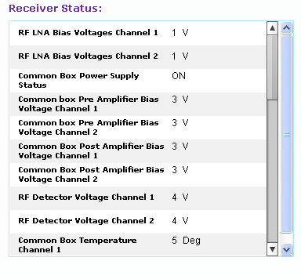

# Batch Mode

## Features

Batch Mode tab is used to execute the batch script containing the set of commands and shows its execution status simultaneously.

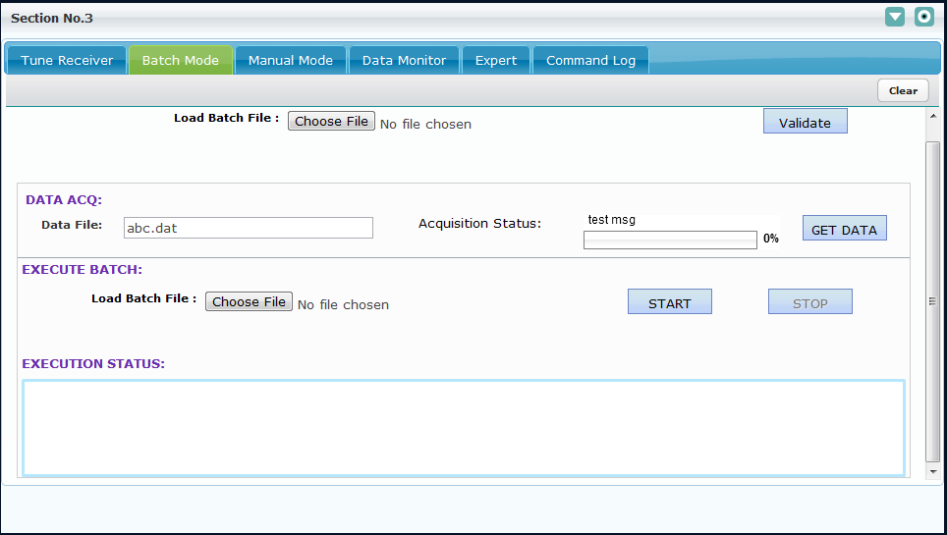

In Batch Mode user can browse the batch file by clicking on the Browse button. The Load Batch File textbox will contain the path of the selected batch file.

#### Validate Button

Validate button is used to validate the selected batch script. If the Batch Script is valid, user will get the success message and if the batch script is invalid user will get the failure message.

#### Success Message

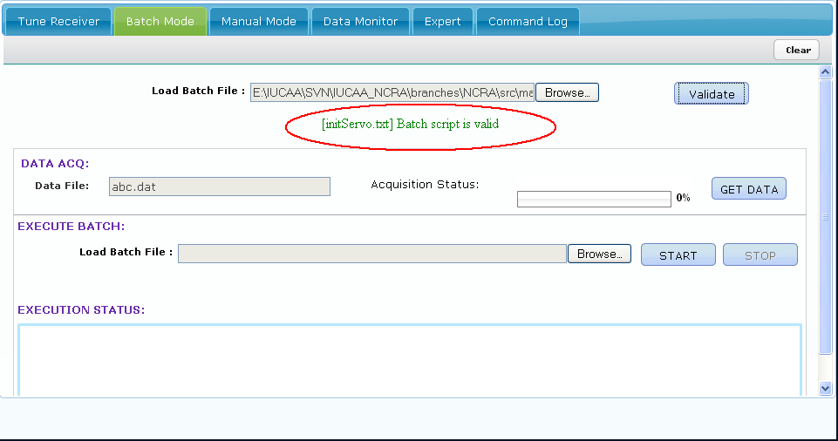

#### Failure message

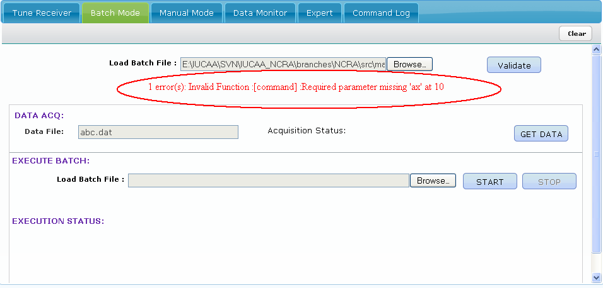

#### DATA ACQ

The DATA ACQ section displays the data file name and the acquisition status in percentage. The acquisition status is received in backend monitoring parameter **acq-percentage** . Also a message can be sent in monitoring parameter **acq-message** which will get displayed above the progress bar.



#### GET DATA

The GET DATA features allows user to download the Astronomical data on to user’s machine. On clicking GET DATA the Astronomical data file is pushed to user’s machine. The browser may or may not prompt the user on saving data based on the browser settings.

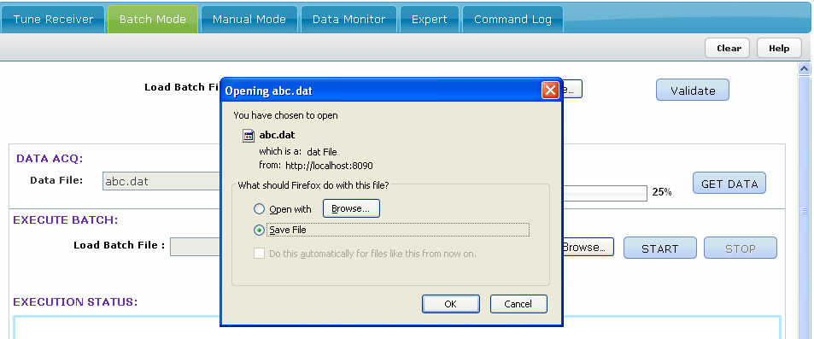

#### Execute Batch Section

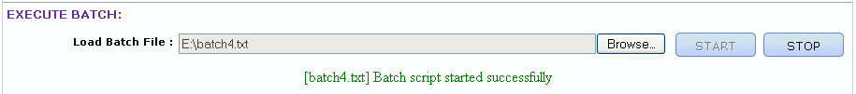

Under this section user selects the batch file by clicking on the browse button. Initially the Start button is enabled and Stop button is disabled. When User selects the batch script and clicks on the Start button, the Batch execution is started. Once the batch script starts executing, Start button will get disabled and ‘Stop’ button will get enabled. During the execution of the batch script user can anytime click on the Stop button to stop the execution. If user skips validation section and directly starts execution, the batch will be first validated and if valid the execution will start.

#### Execution Status

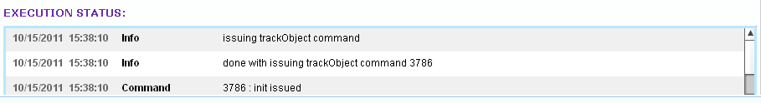

This section shows the status of the batch script which is currently executing. It shows all the info messages, the command execution success/failure messages etc. The messages are displayed in the top-down order i.e. the latest message will appear on the top.

#### Clear Button

On click of Clear button, the contents present in the ‘Load Batch File’ text box and ‘Execution Status’ section will get cleared.

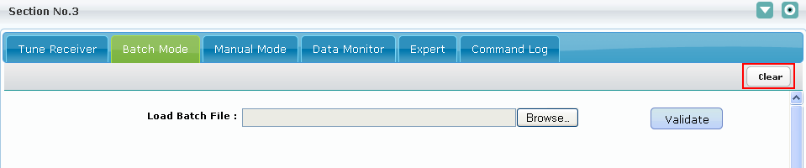

# Manual Mode

This section is used to execute most frequently used commands for servo and backend subsystem to track and manage various telescope operations.

## Manual Mode Command Details

#### TRACK

Moves the telescope to a new source and track it. Internally “trackObject” command is used to track the source.

User can also populate the details of a particular object by entering the object name and pressing enter key, which will enable user to get details of entered source, if present, from the Catalog database maintained in CMS.

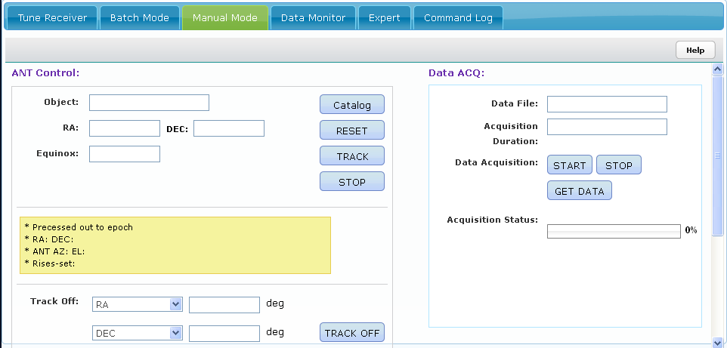

#### RESET

Resets all controls in manual mode tab to default values.

#### STOP

Stops the antenna tracking,positioning or scanning activity.

#### TRACK OFF

This control allows user to track the antenna on the source with customized offsets either in “RA/AZIMUTH” and “DEC/ELEVATION” using two menu driven buttons.

#### POSITION

Position command allows the user to position the antenna at desired azimuth and elevation by giving the antenna co-ordinates for both axes.

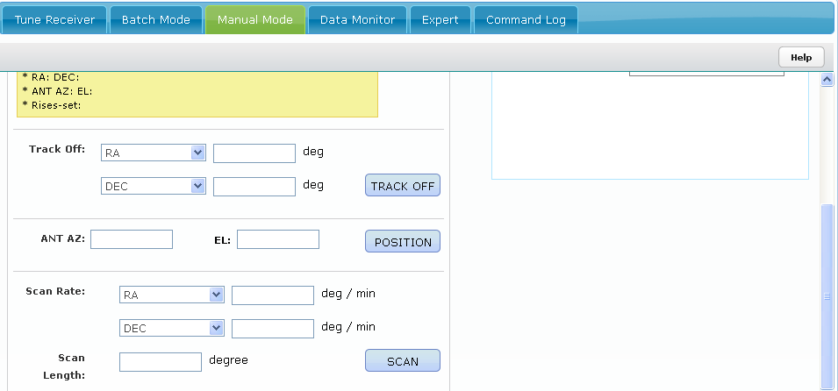

#### SCAN

Take a scan across the given source in “RA”,”DEC”,”AZIMUTH” or “ELEVATION” with specified rate in degree/min and total length of scan in degrees.

#### CATALOG

Click on this button allows user to view catalogs available in database specific to current user and SYSTEM. User can view all the details of the catalog by clicking on the hyperlink provided at source name. User can also sort the catalog based on Source Name, Right Ascension and Declination.

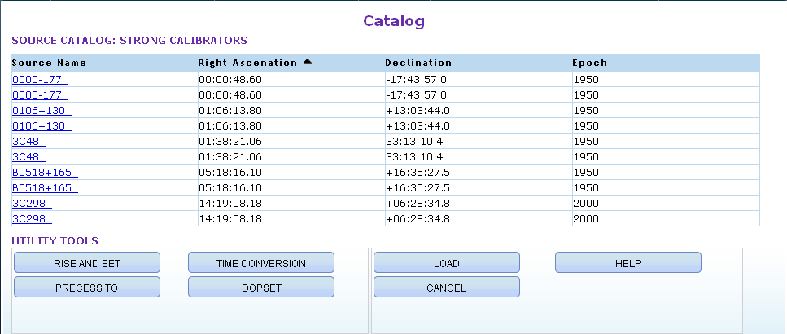

Catalog page provides following functionality:

#### RISE AND SET

Click on this button allows User to calculate IST and LST for Rise, Set and Transit time of the selected source. The selected source is displayed in blue color.

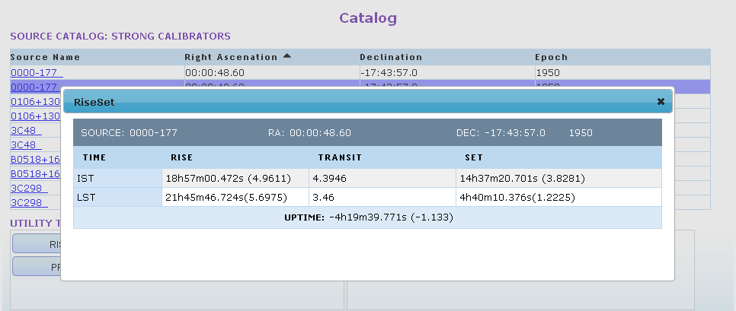

#### TIME CONVERSION

One can convert the given IST into GMT, Julian day and LST.

GMT and Julian Day conversions are also available.

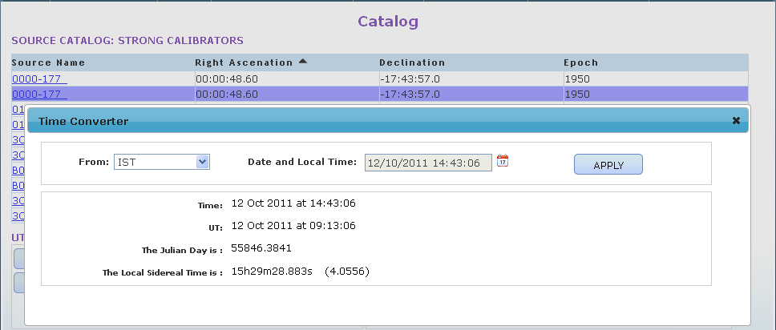

#### PRECESS TO

Precess To allows user to precess the selected source to the given epoch.

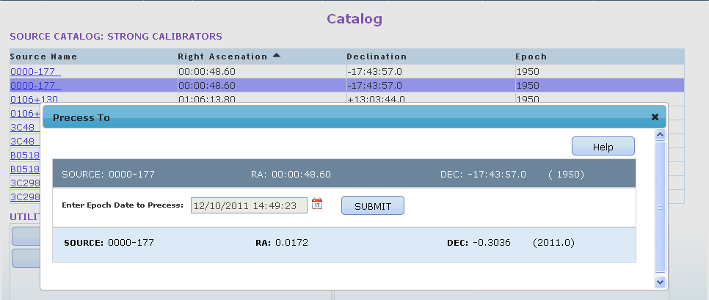

#### DOPSET

Spectral Line observation requires some care for setting the observing frequency since due to Doppler tracking effect actual spectral-line frequency shifts to other value. Hence observing (sky) frequency of the telescope needs to be set to the changed value. Dopset button allows user to calculate and display this value.

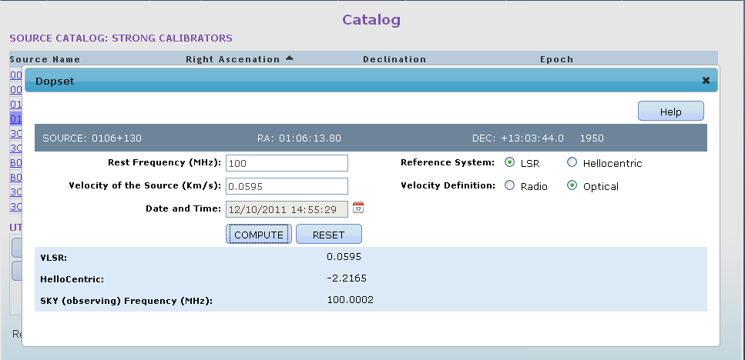

#### CANCEL

Click on this allows user to return to homepage.

#### LOAD

User can select a particular source and click on Load button. The selected source is loaded in ANT Control section of manual mode .Corresponding precessed RA , precessed DEC, precessed Epoch, Azimuth, Elevation, Rise, Set values are calculated and displayed in yellow box as shown below.

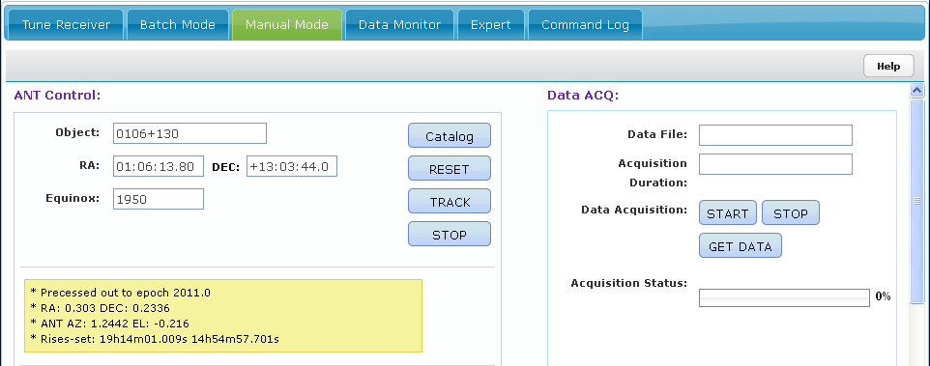

#### Loading an object having epoch value as “GALCT”

Whenever user tries to load an object having epoch value as “GALCT” the corresponding ra, dec contains Galactic latitude and longitude. Then from the given Galactic latitude, Galactic Longitude and epoch value ra, dec are calculated and loaded.

For Example: User tries to load an object named “CASA” having epoch value as “GALCT”.

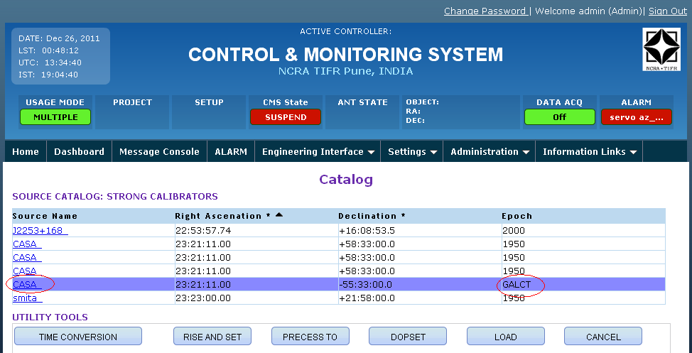

Here Right Ascenation and Declination contains Galactic latitude and longitude, corresponding ra, dec will be calculated and loaded as shown below.

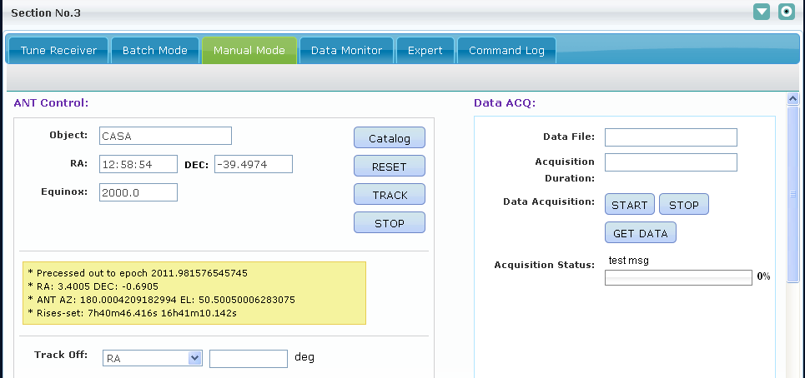

Similarly rise, set, precess ra, precess dec, dopset calculation will also be affected whenever user selects an object having epoch as “GALCT”.

## Data Acquisition Command Details

The Data ACQ section provides interface to execute commands which starts and stops data Acquisition. It also allows downloading the captured Astronomical data on user’s machine.

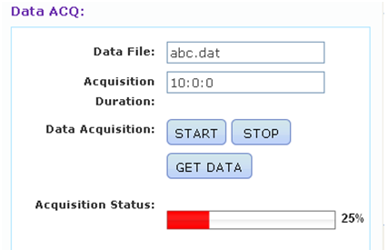

#### START

Start button sends the command to wrapper which starts the actual data acquisition for given duration. User needs to specify the name of the data acquisition file where astronomical data will be captured on data server.

#### STOP

User can instruct the backend subsystem wrapper to stop the data acquisition using STOP button.

#### GET DATA

The GET DATA features allows user to download the Astronomical data on to user’s machine. On the click of GET DATA button the Astronomical data file is pushed to user’s machine. The browser may or may not prompt the user on saving data based on the browser settings.

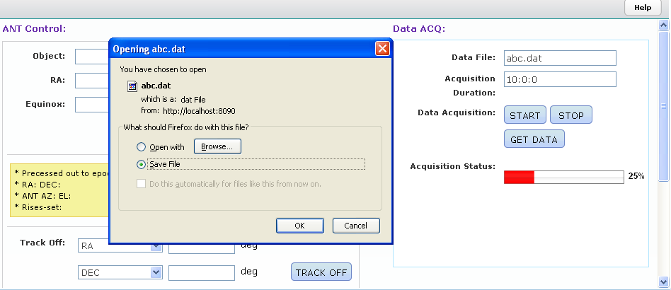

#### DATA ACQISITION STATUS

This progress bar reflects the status of data acquisition as sent over by wrapper.

## Command Execution Status

Once user executes any command in Manual mode, command execution status is displayed in status bar provided in manual mode. Command execution status is also displayed in message console.

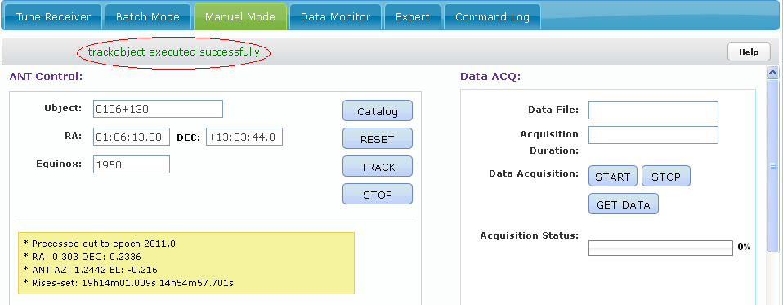

# Data Monitor Tab

This section is used to display chart recorder, spectral and pulsar line plots.

## Data Monitor Tab Sections

This tab contains chart recorder plot, pulsar plot, and spectral plot data. Plot drop down option provides the user to select the plot.

Preference – Preference button provides the preference page for the selected plot

Start – Starts plotting the data/rendering the image as per option selected in plot drop down control

Stop – Stops plotting the data/rendering the image as per option selected in plot drop down control

### Chart Recorder

Chart recorder plots the monitoring parameters values, at any point of time maximum of 3 monitoring parameters can be plotted.

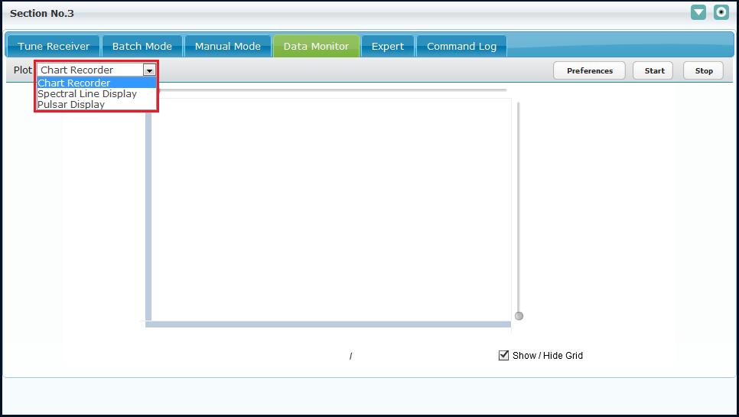

#### Chart Recorder Preference

Chart recorder preferences UI is a dynamically generated UI, using ChartRecorder.xml and ChartRecorder.xsl.

User can dynamically add or delete parameters on UI by modifying ChartRecorder.xml

It allows user to set the chart recorder’s x scale and y scale values.

* X scale is always time and it’s start and end range value varies in between 0 to 24, and interval value divides the start and end range into intermediate parts
* Y scale may vary between Amplitude or Power; user can add more options for it, for example Voltage, Time etc.
* Refresh interval indicates after how many milliseconds the plot should get updated with latest data from wrapper via monitoring information
* Monitoring Parameters section allow user to select the monitoring parameters to plot, user can select maximum 3 parameters.
* Submit – Submitting the user preference values.
* Reset – Reset the user preference all values
* Cancel – Close the user preference.

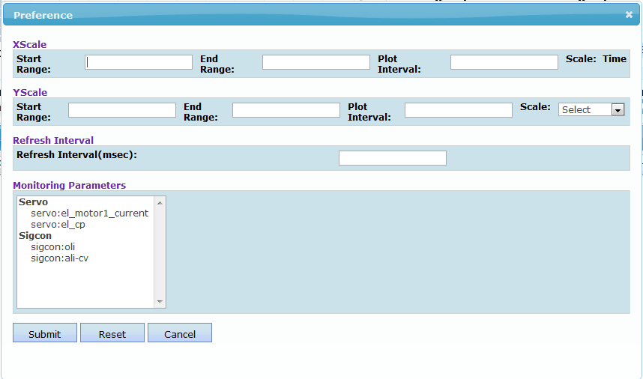

After submitting the Preference, user can see status message “Chart recorder preference set, Please start the monitoring”. And the user can view the selected monitoring parameter plotted (with current available value, however they are not updated until you click on start button). Also the legends are provided as below.

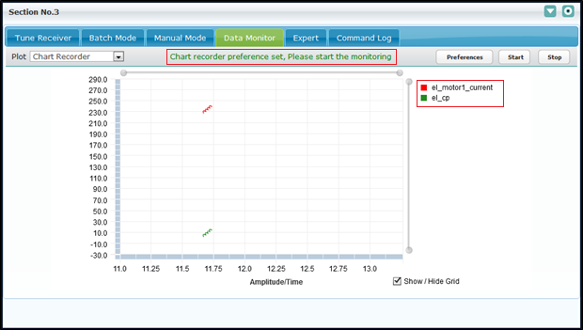

If monitoring is already started and user submits new preference then user will get below informative message and use does not require restarting the monitoring again.

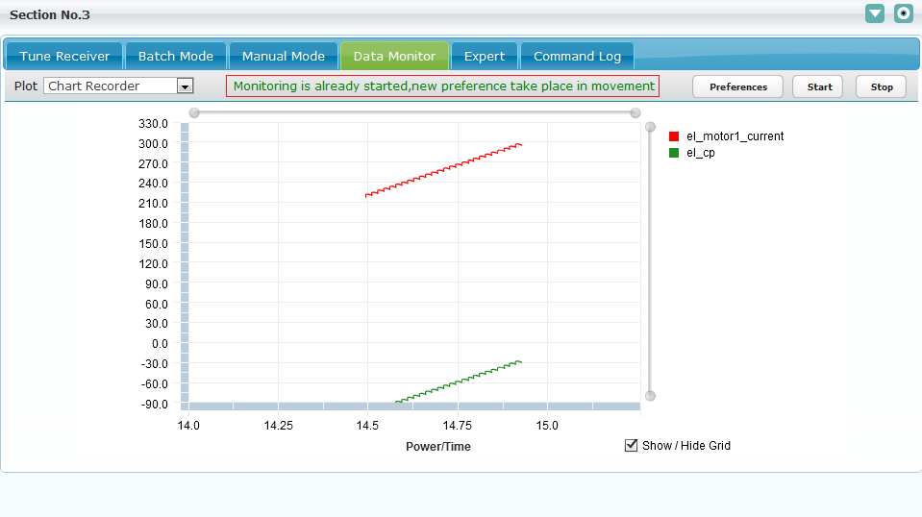

#### Chart Recorder Start

Start – Actually starts plotting monitoring parameters, a confirmation message is displayed before plotting parameters.

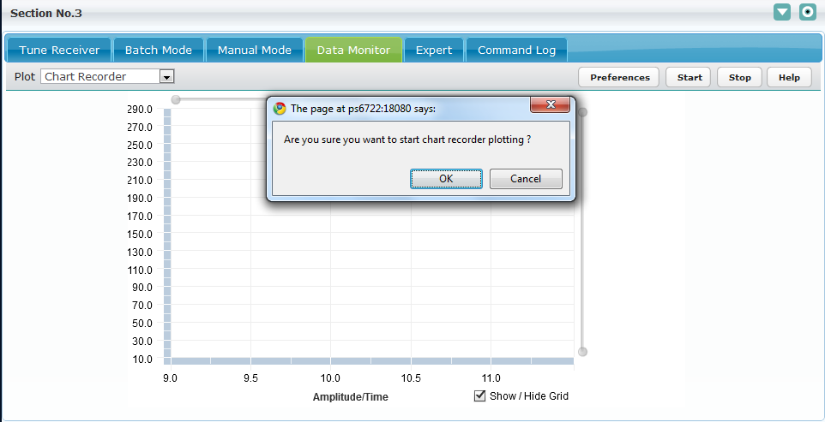

Click on “OK” user will get the below message depend on the selected x-scale “end range” of preference.

1. If x scale end range (is end time) do not pass away than user will get below success message.

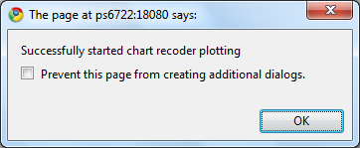

User can see the monitoring plot as shown; here selected 2 monitoring parameter, if user selects the 3 parameters on preference then user can see 3 plots here.

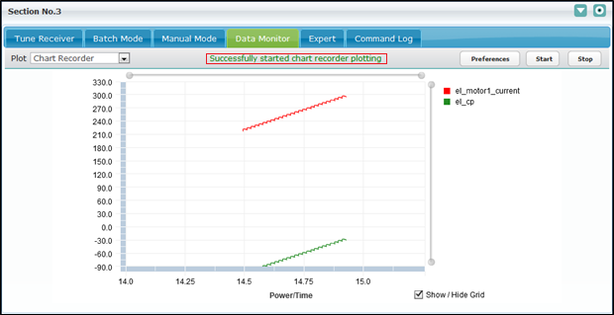

1. If x scale end range (is end time) passed than user will get below informative message.

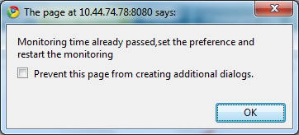

Press “OK” and user see the same informative message on chart recorder as below,

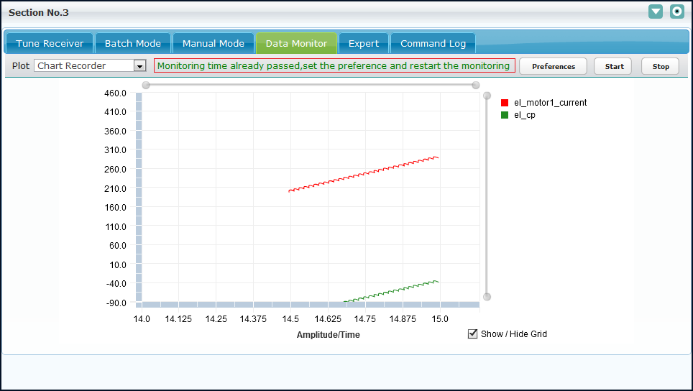

#### Chart Recorder Stop

##### ***Manual Stop***

User manually stops the chart recorder plotting as below

Stop – Click on stop button will stop the plotting of the monitoring parameter.

Click on stop button, shows the confirmation message as shown below.

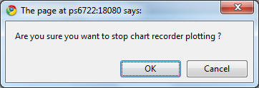

Click on “OK” will stop the plotting of monitoring parameters and user will get success as shown below.

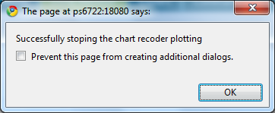

Press “OK” and user see the same informative message on chart recorder as below,

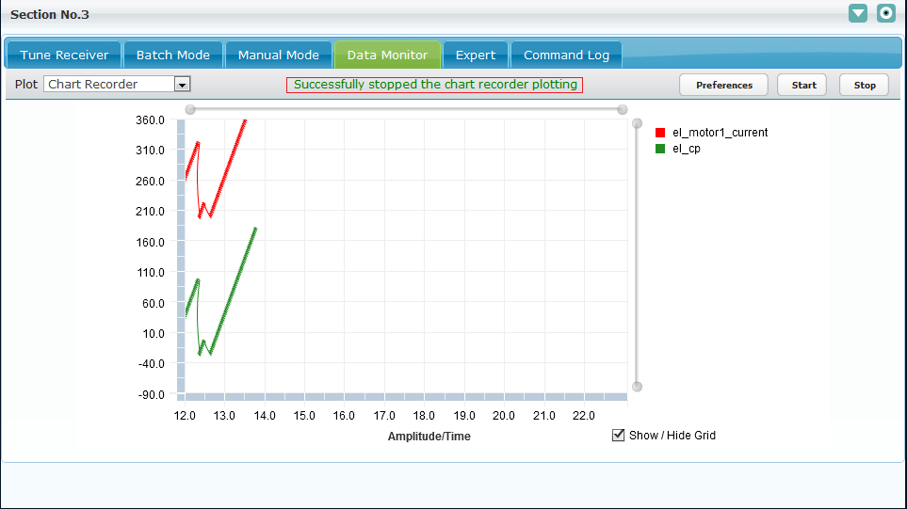

##### ***Auto Stop***

When the time specified in x-scale end time is crossed, CMS automatically stop the chart recorder plotting and user will get below status message.

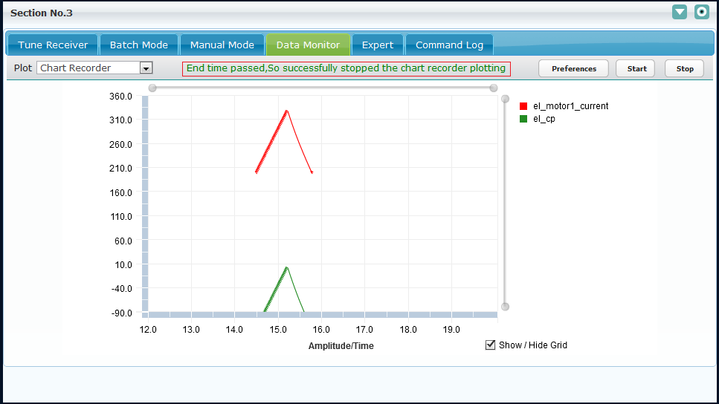

### Spectral Line Display

Spectral Line display plot can be plotted by selecting the “Spectral Line Display” from the plot dropdown. It displays the discrete and accumulated spectrum.

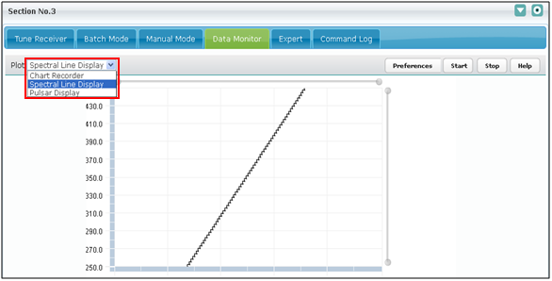

#### Spectral Line Preference

Spectral Line display preferences UI is a dynamically generated UI, using SpectralLineDisplay.xml and SpectralLineDisplay.xsl. User can dynamically add or delete parameters on UI by modifying SpectralLineDisplay.xml.

It allows user to set preferences of Spectral line dialog panel, where user can customize spectral line display along with Data monitoring parameters like update interval, integration, polarization and scale of X-axis. User cannot modify the meta- data section parameters. Meta data can be modified through tune-receiver (Digital back-end section) or expert tab (trackobject command). Manual mode tab also provides option to update the Meta data parameters such as data file, acq-duration etc.

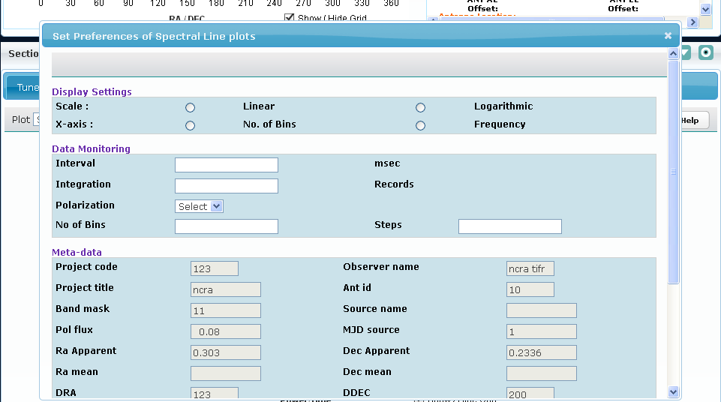

##### Spectral Preferences submit

After providing the Display Settings and Data Monitoring Settings user can click on the ok button in order to submit the preferences. Internally “**sendspectralplottingdata**” command of backend subsystem is executed. Spectral line display plot is then rendered on screen from backend monitoring information.

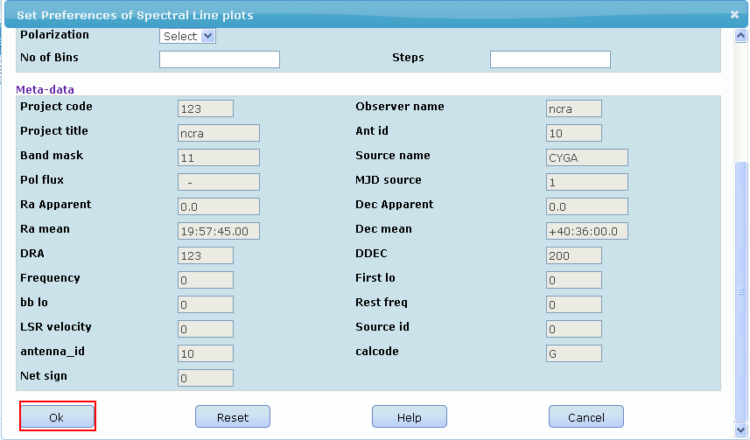

Command execution status is displayed to user in status window.

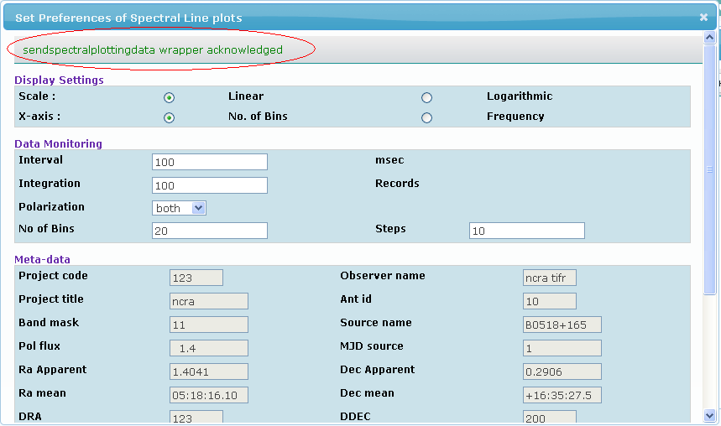

##### Spectral Preferences reset

On clicking Reset button all the Spectral Line display preferences dialog are reset to default values.

##### Spectral Preferences cancel

The cancel button provides the user the option to cancel the preferences and return back.

#### Spectral Line Start

Actually starts plotting spectral line plot, a confirmation message is displayed before plotting parameters.

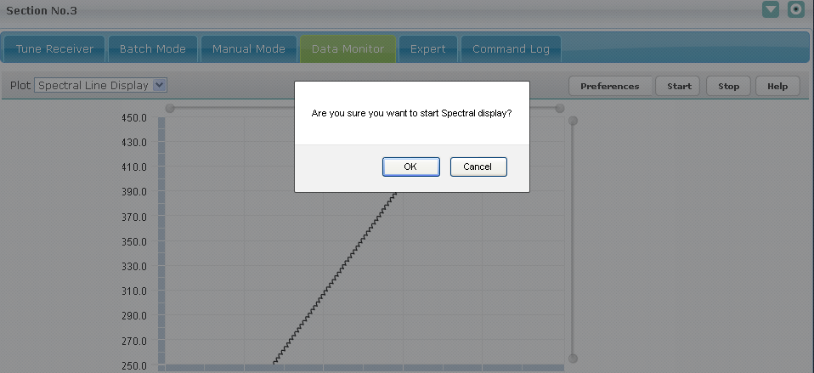

Click on “OK” invoke the “startspectralplottingdata” command, which actually sent to digital backed. Digital backend on receiving this command will send the image data in below format periodically and that image will be populated here.

**Image data response format:**

                <responses><response><seq>1</seq><id>41</id><name>doMon</name><systemid>backend</systemid><version>1.0</version><timestamp></timestamp><code>10</code><event>15</event><message>wrapper ack</message><data><param><name>spectral</name><value>**real image data in base 64 encoded format** </value></param></data></response></responses>

Currently .jpg and .png image are supported

Here, <name> contain value should be “spectral” and <value> contain base 64 encoded image data.

This response should be sent on event port which is mention in cms.properties

#### Spectral Line Stop

To stop plotting the spectral plot user can click on stop button.

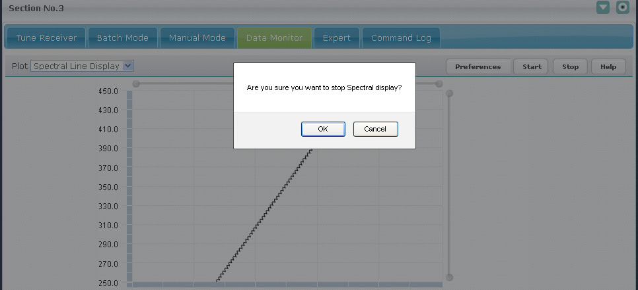

Click on “OK” invoke the “stopspectralplottingdata” command, which actually sent to digital backed. Digital backend on receiving this command will not send any image data.

### Pulsar Line Display

Pulsar Line display can be plotted by selecting the “Pulsar Line Display” from the plot dropdown. It displays the current profile of pulsar, folded/accumulated profile of pulsar and band shape spectrum in the form of image as sent over from wrapper. However this functionality would be implemented in upcoming releases.

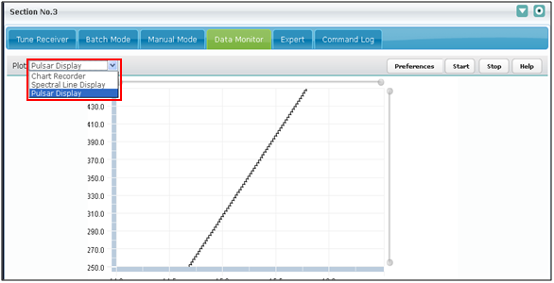

#### Pulsar Line Preferences

Pulsar display preferences UI is a dynamically generated, using PulsarDisplay.xml and PulsarDisplay.xsl. User can dynamically add or delete parameters on UI by modifying PulsarDisplay.xml.

It displays the current profile of pulsar, folded/accumulated profile of pulsar and band shape spectrum in the form of image as sent over from wrapper. However this functionality would be implemented in upcoming releases.

The pulsar visualization/monitoring specifically depend upon sampling interval, dispersion measure and period of pulsar at given frequency. These variables along with display settings can be done using the set preferences of pulsar display. User however cannot modify the meta- data section data .Meta data can be modified through tune-receiver, expert tab or manual mode tab.

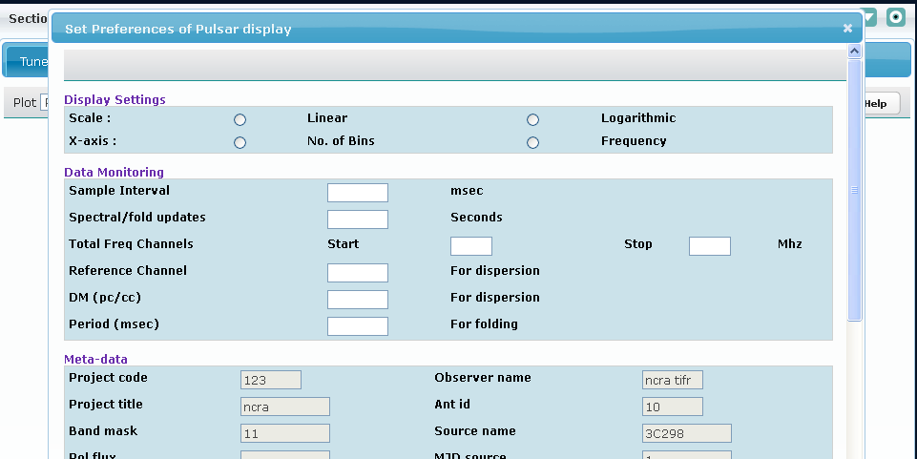

##### Pulsar Preferences submit

After providing the Display Settings and Data Monitoring Settings, user can click on the ok button in order to submit the preferences. Internally “**sendpulsarplottingdata**” command of backend subsystem is executed. Spectral line display plot is then rendered on UI in form of image as sent over by backend subsystem via wrapper.

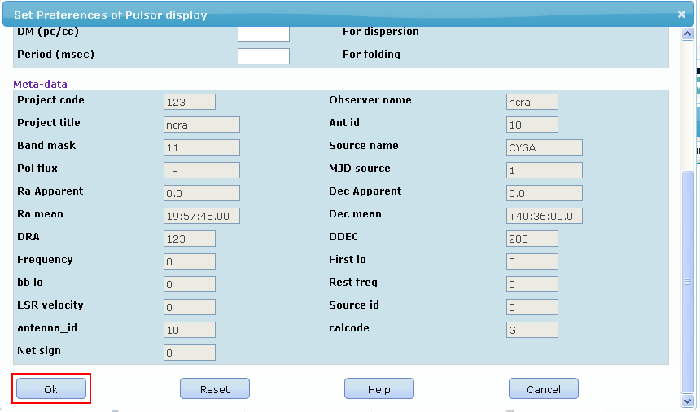

Command execution status is displayed to user in status window.

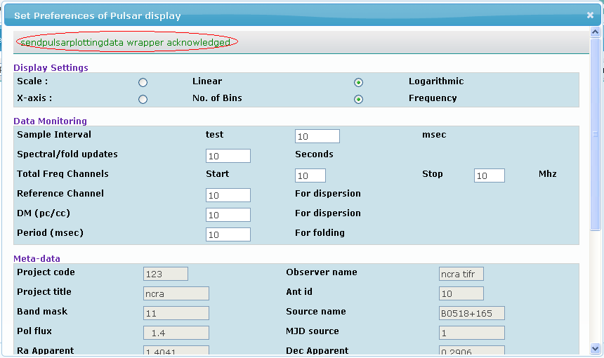

##### Pulsar Preferences reset

On clicking Reset button all the Pulsar Line display preferences dialog are reset to default values.

##### Pulsar Preferences cancel

The cancel button provides the user the option to cancel the preferences and return back.

#### Pulsar Line Start

Actually starts plotting Pulsar line plot, a confirmation message is displayed before plotting parameters.

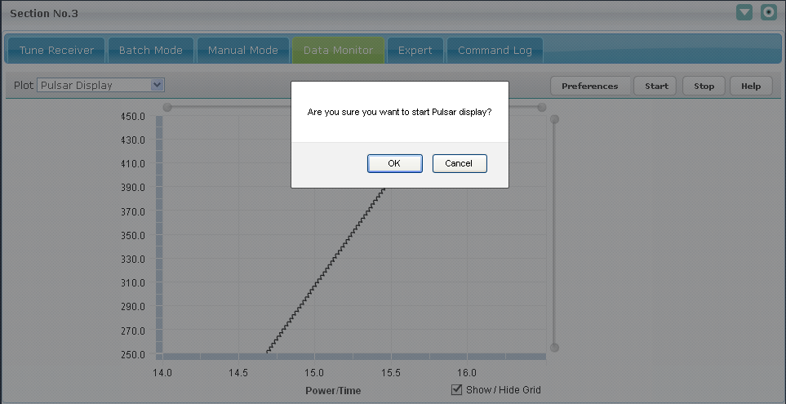

Click on “OK” invoke the “startpulsarplottingdata” command, which actually sent to digital backed. Digital backend on receiving this command will send the image data in below format periodically and that image will be populated here.

**Image data response format:**

                <responses><response><seq>1</seq><id>41</id><name>doMon</name><systemid>backend</systemid><version>1.0</version><timestamp></timestamp><code>10</code><event>15</event><message>wrapper ack</message><data><param><name> pulsar</name><value>**real image data in base 64 encoded format** </value></param></data></response></responses>

Currently .jpg and .png image are supported

Here, <name> contain value should be “pulsar” and <value> contain base 64 encoded image data.

This response should be sent on event port which is mention in cms.properties

#### Pulsar Line Stop

To stop receiving the pulsar plot user can click on the stop button.

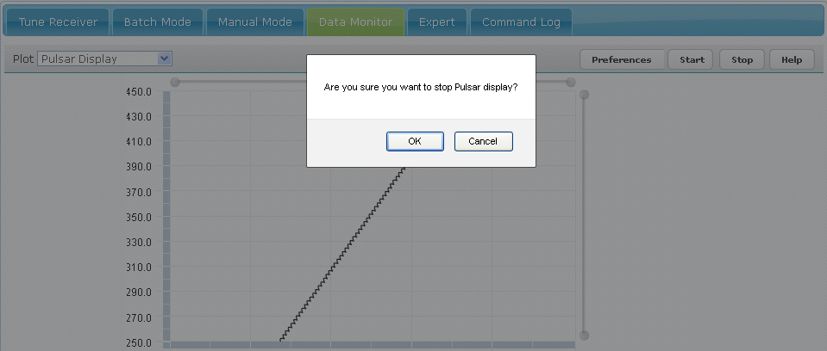

Click on “OK” invoke the “stoppulsarplottingdata” command, which actually sent to digital backed. Digital backend on receiving this command will not send any image data

# Expert Tab

This section is used to execute all the possible commands configured for a given subsystem. This is an expert level feature and permission for this should be chosen carefully.

## Expert Tab Features

### Select Subsystem Dropdown

This Dropdown will contain the list of all the subsystems whose entries are configured in ‘ncra-subsystemconfig.xml’ file. User can select a subsystem from the dropdown. The All option displays the commands of all configured subsystems in the commands list.

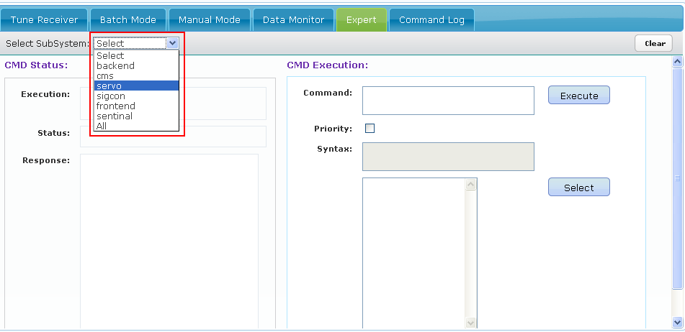

### CMD Execution Section

When user selects a subsystem from the ‘Select Subsystem Dropdown’, all the commands present in commands configuration file of that subsystem will appear in the last box of “CMD

Execution” section as shown in figure below. Here user has selected ‘servo’ subsystem in ‘Select Subsystem’ dropdown and all the commands of that subsystem will appear.

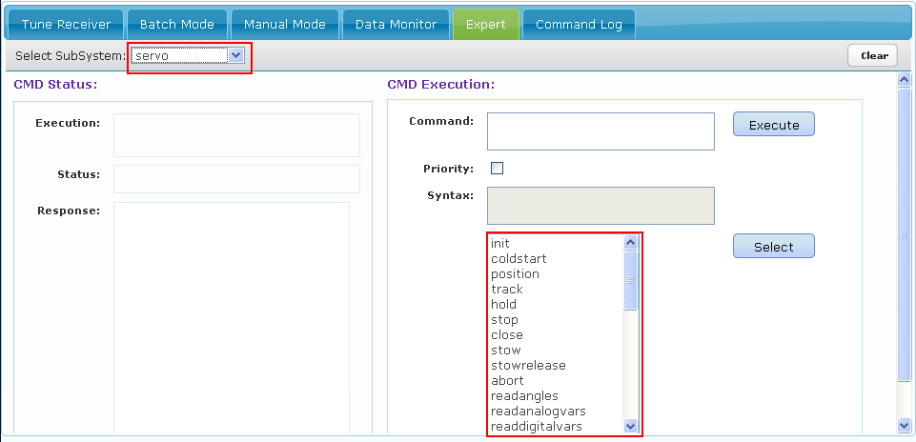

User can select the command to be executed in 3 ways.

1. Click on the command name and press ‘Select’ button.
2. By double click on the command name.
3. By selecting or typing the command and pressing enter key.

After selecting the command in first two ways, the command name with parameter names will appear in ‘Syntax’ box and command name with sample parameters will appear in ‘Command’ box as shown in the figure below. For the third option user needs to be aware of the command syntax before executing the command.

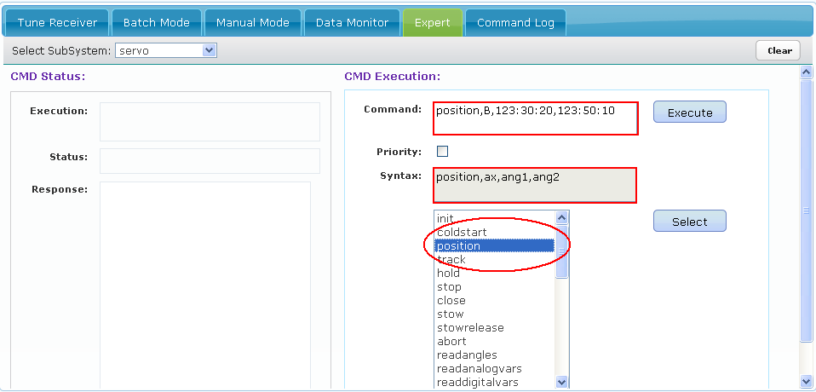

Priority checkbox is used to set the priority of the command. If it is checked the command will be sent with priority as 1 (i.e. High Priority) otherwise it will be sent with the priority as 0. When user clicks on ‘Execute’ button command execution will start.

### CMD Status Section

Once the command execution starts the ‘Execution’ box shows ‘Executing command name’. For example if position command is getting executed ‘Execution’ box will show ‘Executing position. Status box will show the status of the command. For example when the command is issued, the Status box will show ‘Command Issued’.

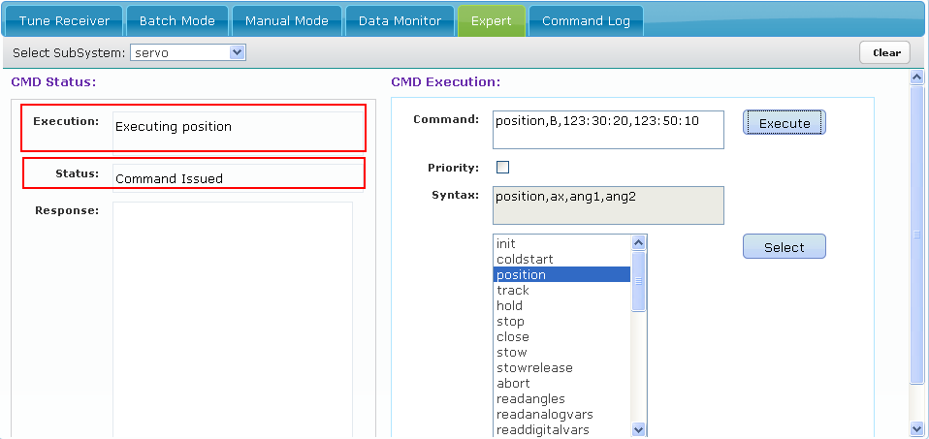

When the command executed successfully ‘Execution’ box will show the sequence number of the command and the command name. Status box will show ‘success’. The ‘Response’ box shows the response received from the Wrapper as shown in the figure.

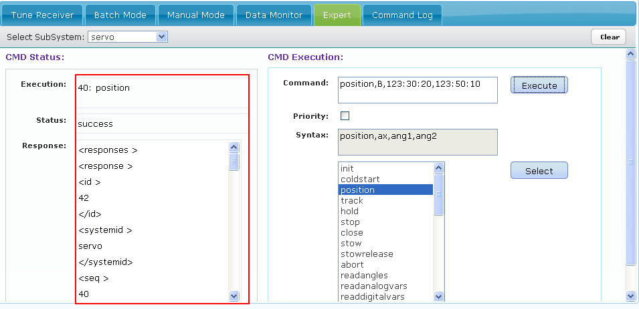

# Command Log

## Command Log Details

Commands executed by user are logged in database. For each Command, request sent and all responses received from wrapper are saved in database. User can specify start and end date time and can view logs of commands executed in that period of time. A logged in user, whose role is other than expert can view logs of only self-executed commands. User can view logs of particular subsystem or all subsystems, by selecting it from “Select Subsystem” dropdown.

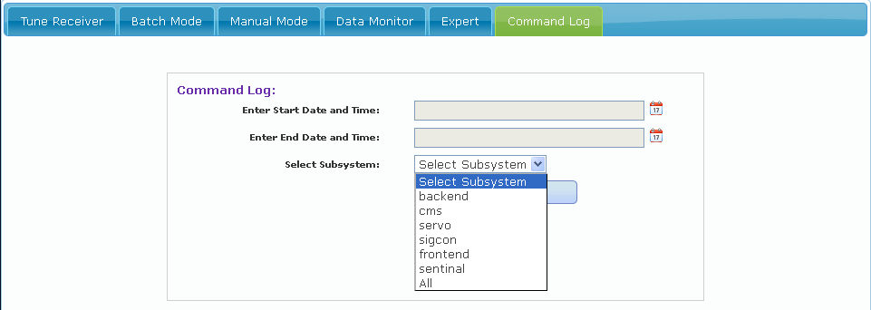

However an Expert has an option to select a particular user or all users along with subsystem to view logs.

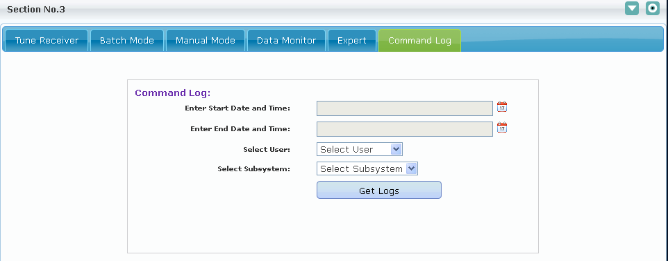

Once user specifies start and end date time, he can view logs present in database.

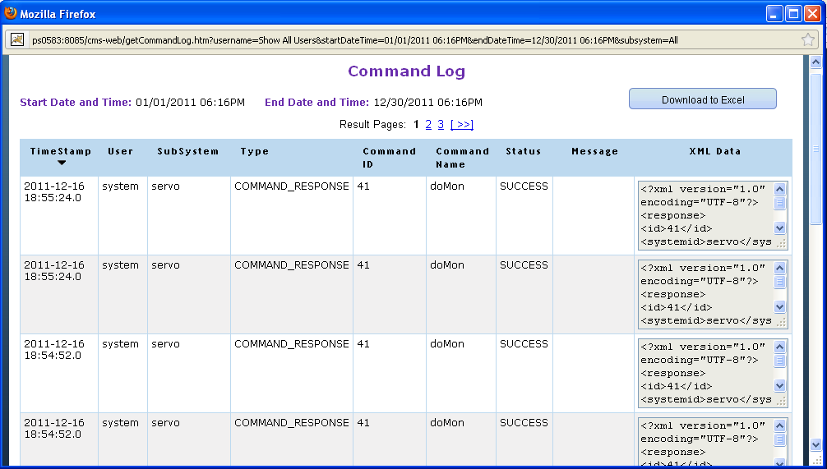

#### Download to Excel

Enables user to download the logs to an excel sheet and save them.

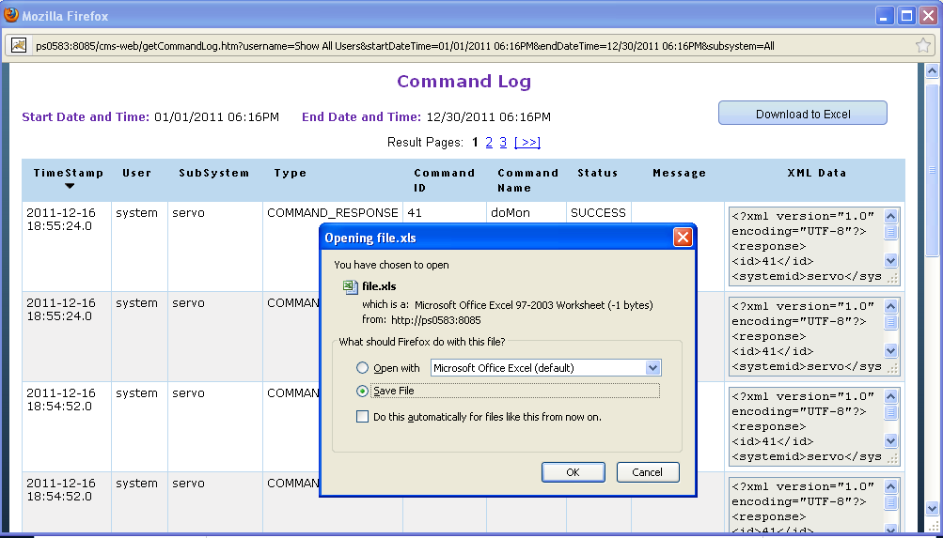

# Meta Data

This section displays the Meta data values

## Meta Data Details

Meta Data tab displays the Meta data information configured in MetaData.xml

Meta Data tab is by default visible to only “admin” and “expert” users.

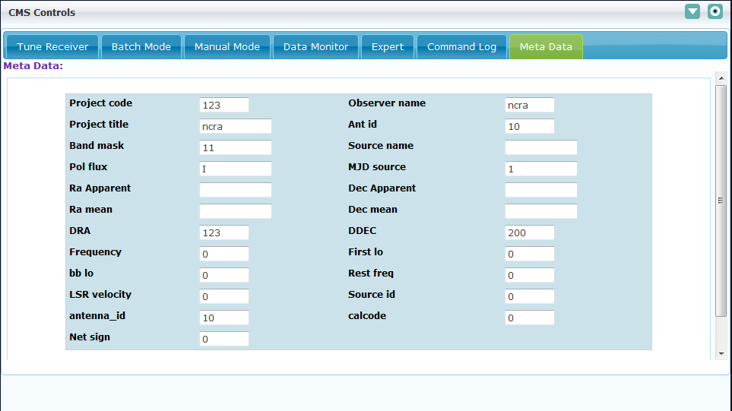

# Engineering UI

This section allows an engineer to configure various engineering parameters related to the individual subsystems.

## Engineering UI Sections

The Engineering UI is divided into 5 sections as specified below. For details of configuring these sections refer to **Engineering UI Configuration NCRA** document. The structure of the UI will vary as per the XML configuration.

### Status Parameters:

The status parameter contains the parameters that indicate the status of the subsystem. The status parameters section and parameters will be visible in UI as displayed below:

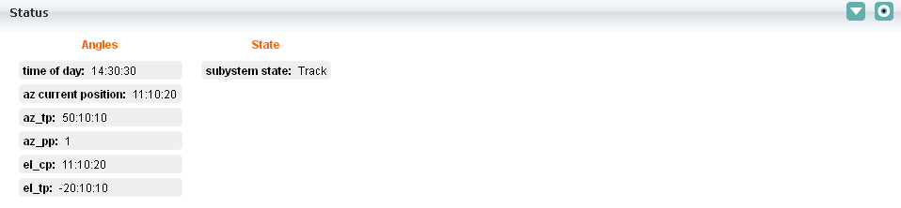

### Raw Parameters

The raw parameters section displays the raw data sent by a subsystem. This data is sent through monitoring parameter with name **rawstream**.

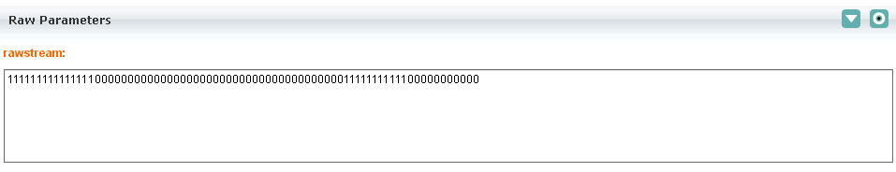

### Monitoring Parameters:

The monitoring parameters section displays the values of the subsystem Monitoring parameters. The Monitoring parameters section will be visible in UI as displayed below:

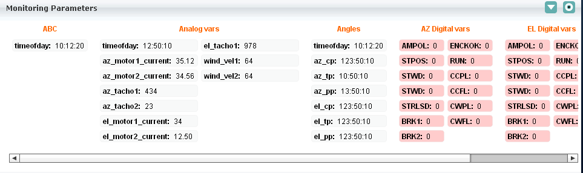

All status and monitoring parameter values are updated when CMS receives monitoring parameters response from wrapper.

### Basic Commands:

The basic commands sections displays the buttons for executing basic commands

The basic commands section will be visible in UI as displayed below:

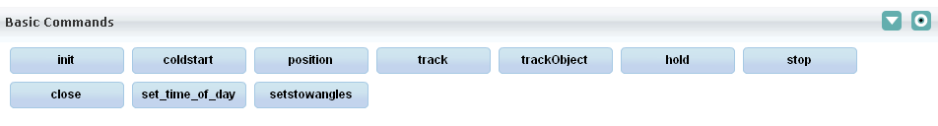

If any command is not configured in subsystemname_commands.xml and if it is executed from this section; the user will get an error message “command not found”.

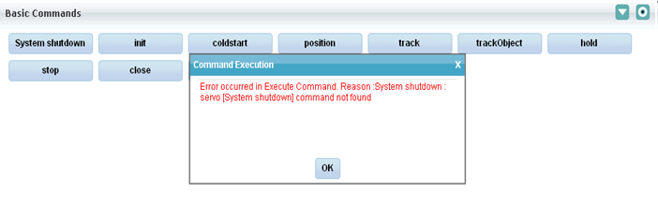

### Detailed Commands:

The detailed commands section includes the commands which are sparingly used. The look and feel of the added command will be similar to the basic command.

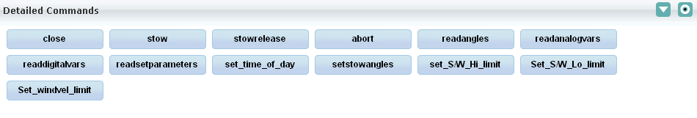

### Trend Plot:

Trend plot plots the one monitoring parameter vs. another monitoring parameter and it is sub system based, means each sub system has its own trend plot to plot monitoring parameters, and their respective configuration files name as <subSystemName>TrendPlot.xml

For example: servo sub system configuration file name as servoTrendPlot.xml

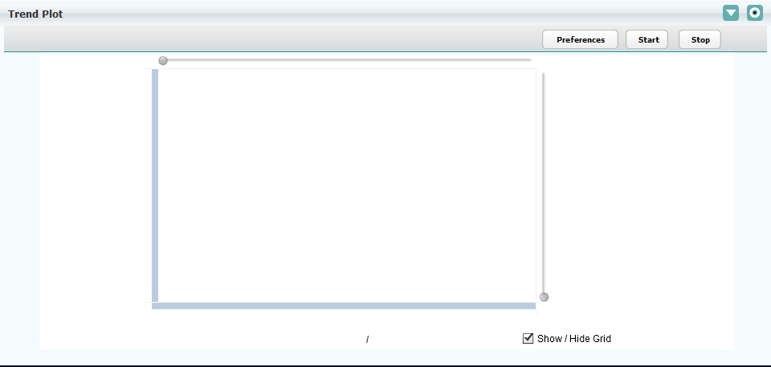

#### Trend Plot Preference

Trend plot preferences UI is a dynamically generated UI, using servoTrendPlot.xml and ChartRecorder.xsl

User can dynamically add or delete parameters on UI by modifying servoTrendPlot.xml

It allows user to set the chart recorder’s x scale and y scale values.

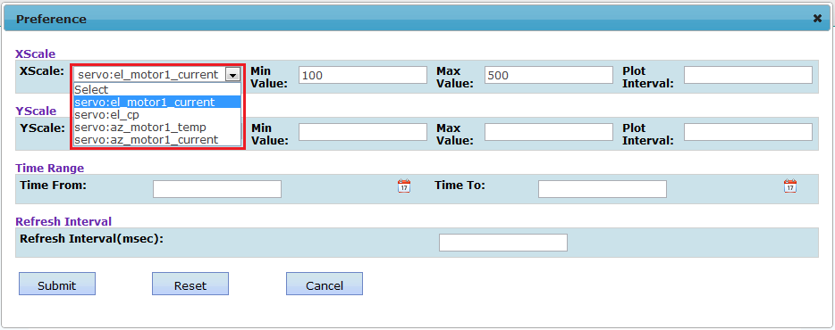

* X scale is a monitoring parameter, when user selects any monitoring parameter, its min and max value automatically populated, if it is configured in configuration file (Please refer to Developer Guide for configuration details).
  + If any of the parameter min and max value not configured in configuration file then user needs to manually enter these values and will get below informative message on preference page.

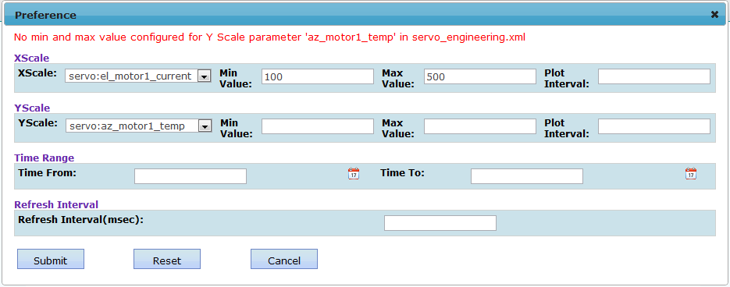

* Interval value divides the min and max into intermediate parts.
* Y scale is same as X scale.
* Time Range is used to see the plot for time period.
* Refresh interval indicates after how many milliseconds the plot should get updated with latest data from wrapper via monitoring information
* Submit – Submitting the user preference values.
* Reset – Reset the user preference all values
* Cancel – Close the user preference.

After submitting the Preference, user can see status message “Trend plot preference set, please start the monitoring” and selected monitoring parameter plotted (with current available value, however they are not updated until you click on start button) as below.

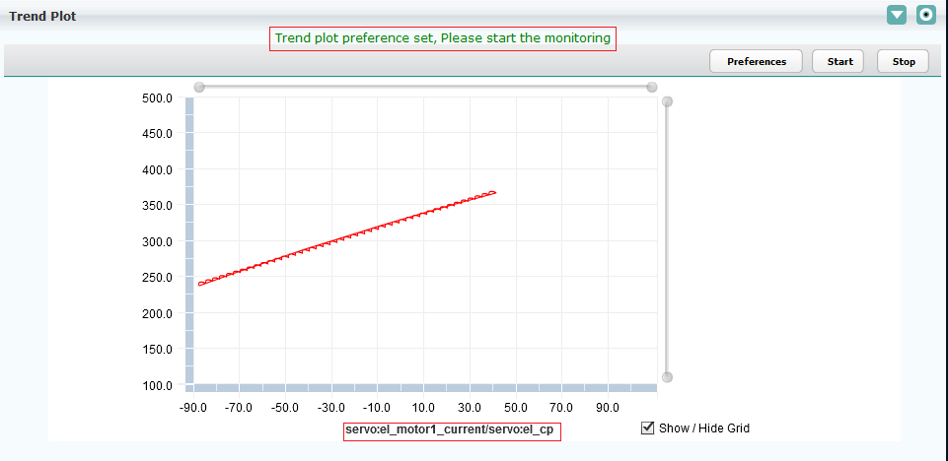

If monitoring is already started and user submits new preference then user will get below informative message and user need not start the monitoring again.

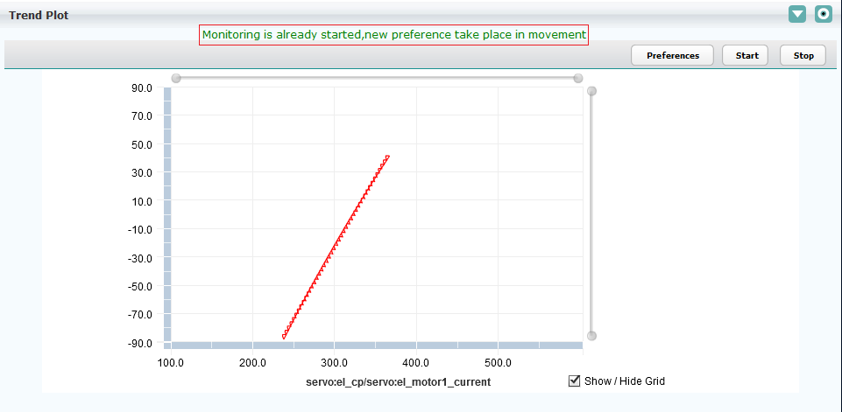

#### Trend Plot Start

Start – Actually starts plotting monitoring parameters, Click on Start button and user will get the message depend on selected value of “Time To” in preference page.

1. If “Time To” is not elapsed already then user will get below success message.

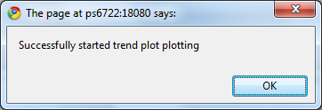

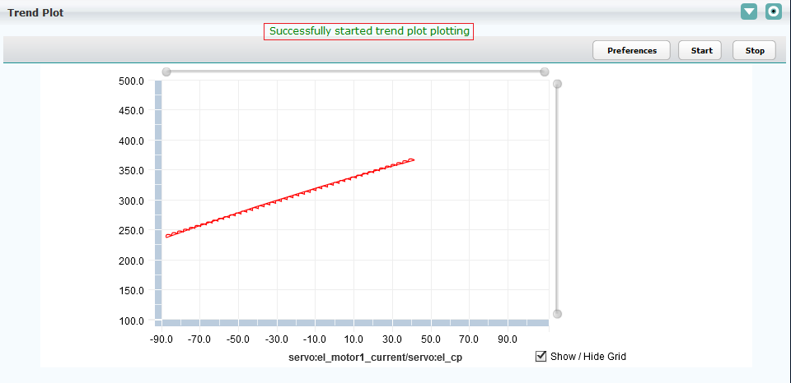

1. If “Time To” is already elapsed then user will get below informative message.



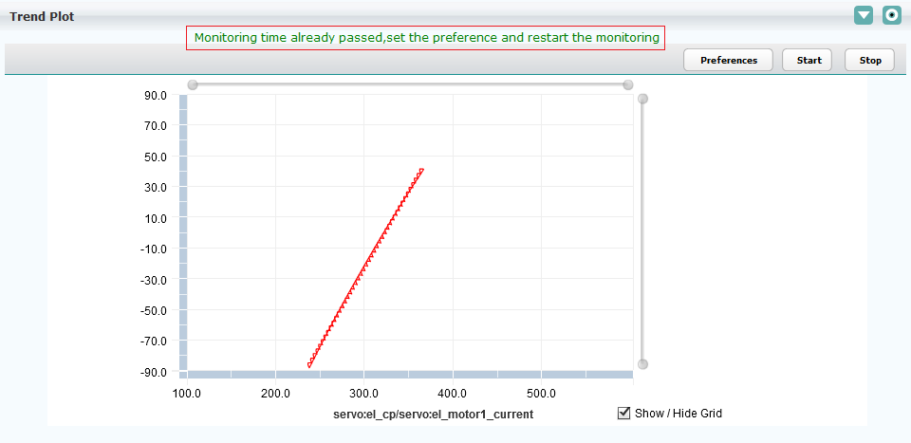

#### Trend Plot Stop

##### ***Manual Stop***

User manually stops the trend plot plotting as below

Stop – Click on stop button will stop the plotting of the monitoring parameter.

Click on stop button, will stop the plotting of monitoring parameters and user will get success as shown below.

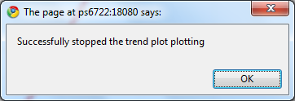

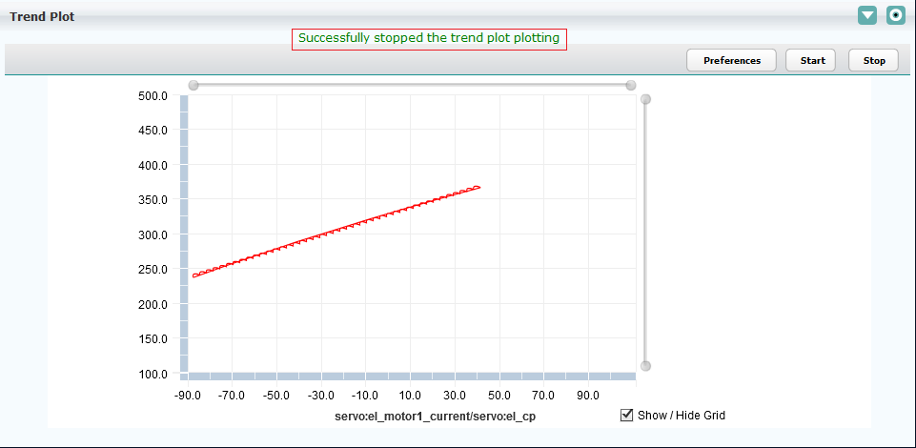

##### ***Auto Stop***

When time mentioned in “Time To” control is elapsed, CMS automatically stops the trend plot plotting.

# State Machine

This is the most important component of CMS; it tracks state of individual sub systems as well state of CMS as a whole system.

It allows taking automated corrective actions in cases of critical alarms and also responds and takes corrective action on CMS side in case of malfunction, asynchronous events received from sub systems through wrapper.

## Start up and Initialization in State Machine

### State Machine start-up

When CMS is started, state-machine always enters the START state and the steps mentioned below are performed:

1. State Machine checks the wrapper connectivity for configurable amount of time if wrapper is not connected then State Machine raises the wrapper down alarms, and moves into SUSPEND state – refer below figure.

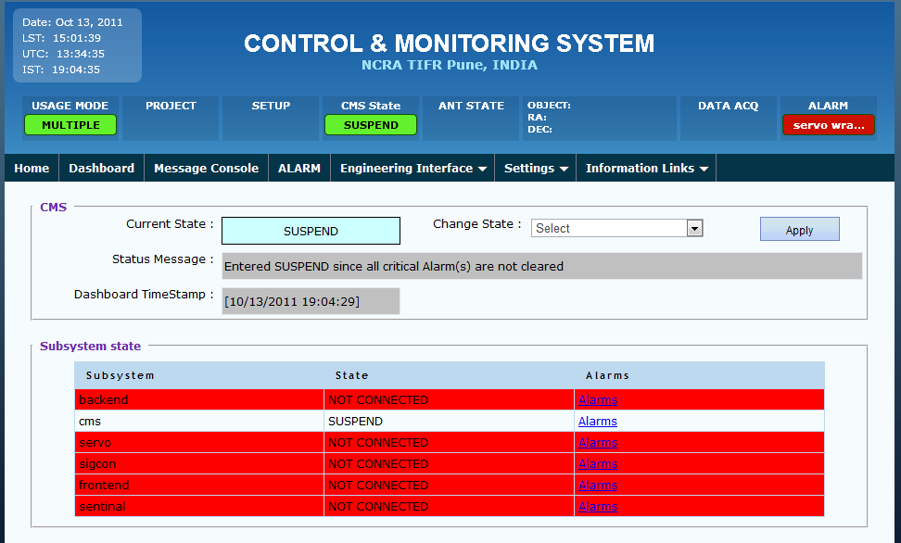

1. To view the alarm for the particular subsystem click on the alarm link. Refer figure below, the alarm raised for servo sub system wrapper down

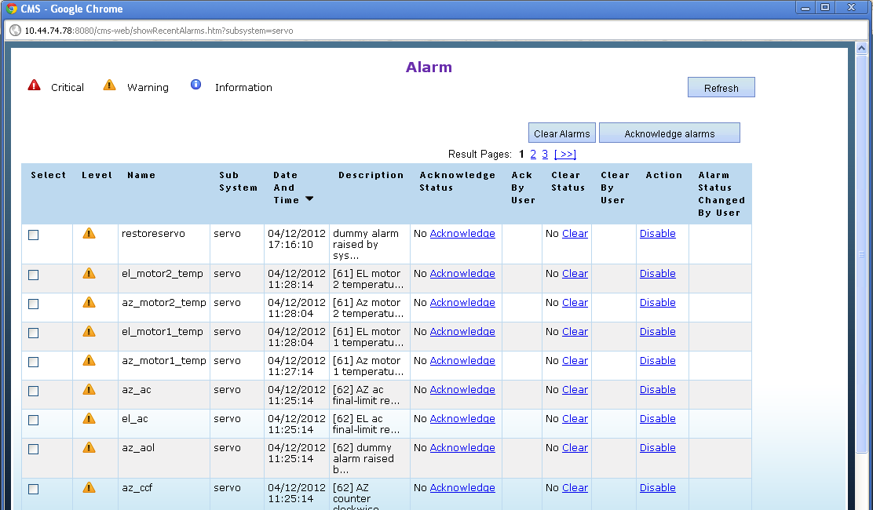

### State Machine initialization

1. If previously state-machine was moved to SHUTDOWN state and when CMS is restarted and all the wrappers get connected then state-machine moves to INIT state and executes initialization script “initAllSubsystems.txt”.
2. After successfully completion of the INIT state state-machine moves into NORMAL state and as displayed below:

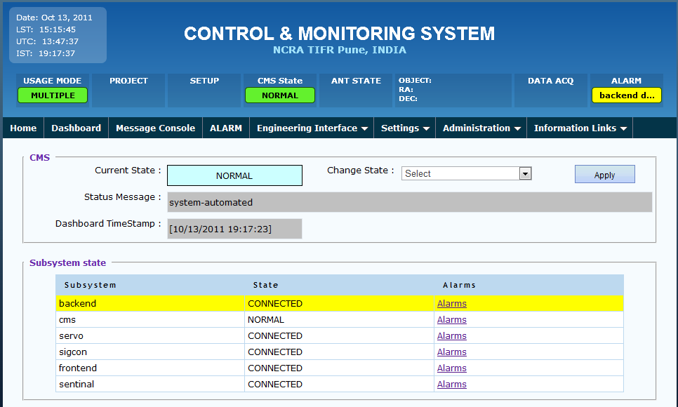

1. If initialization is not successful then CMS raises the initialization failure alarm as show below and moves to SUSPEND state.

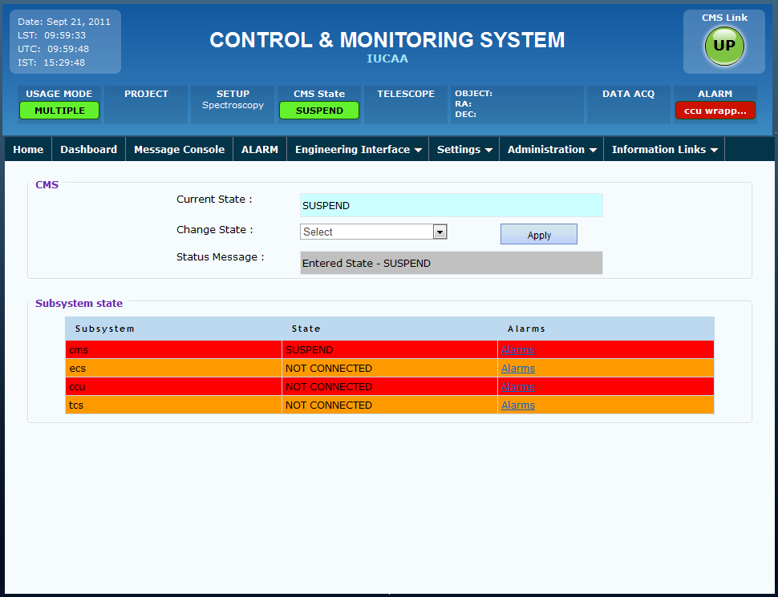

1. Click on the alarms link to view the alarm raised for the particular subsystem.

### State Machine initialization on power failure

1. If state-machine was not moved to SHUTDOWN state in case of abrupt power failure and wrappers get connected after CMS start-up then state-machine moves to INIT_ON_POWERFAILURE state as shown in below screenshot. In this state state-machine executes all the sub system restore scripts as specified in “init_on_powerfailure.txt” batch script.



1. If CMS couldn’t restore the sub system then state-machine raises the alarm for initialization failure and then moves into SUSPEND state

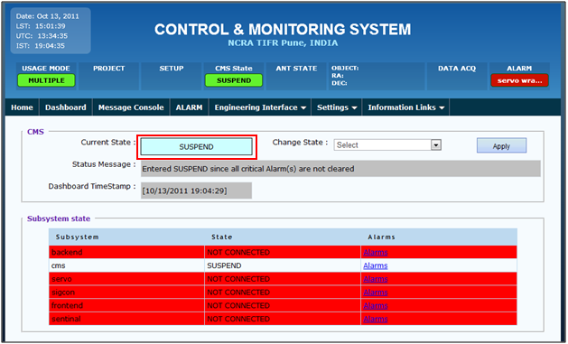

1. If state-machine either successfully completed INIT or INIT_ON_POWERFAILURE than state-machine moves into NORMAL state and no alarms are shown below

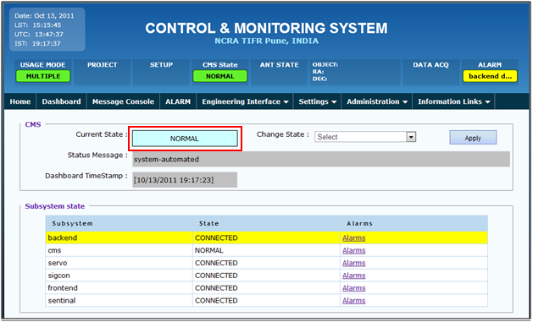

## Viewing the alarms

To view the recently raised alarms go to Dashboard Tab

1. Dashboard shows the current state of the CMS, and other sub system states, along with alarms link, depending on the alarm severity and level the background color of subsystem is changed.
2. Click on alarm links show sub system specific alarms details and their severity level along with color.



1. Alarms levels as below
   1. If alarm level 5 then background is shown in red color
   2. If alarm level equals 3 or4 then background shown in orange color
   3. If alarm level equals 1 or 2 then background shown in yellow color

Alarm level below 1 is treated as info level only.



## Clearing and acknowledging the alarms

### Alarm clearing

1. User who has been granted the permission to clear the alarm can only view the Clear Status link or clear Alarm button. Other users can only view the current clear status of alarm. To grant user permission to clear the alarm refer section 1.2.2.11.1 Add Role.
2. Assuming user has been granted clear alarm permission ,when user clears the alarm it will ask for the confirmation to clear the alarm, if user selects ok, the alarm gets cleared and the background color changes for the particular subsystem, and user name is updated in clear by user column.

For e.g. in below figure the critical level alarm wrapper down for servo subsystem is being cleared.

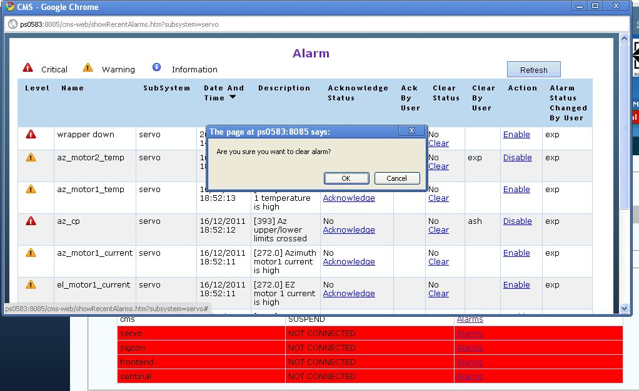

1. After clearing the alarm, the backend alarm page and dashboard will look like as below,

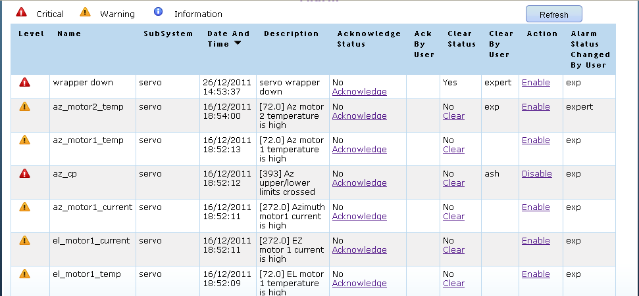

1. If all critical alarms are cleared CMS will enter the state prior to entering SUSPEND state and Status message will display as below:

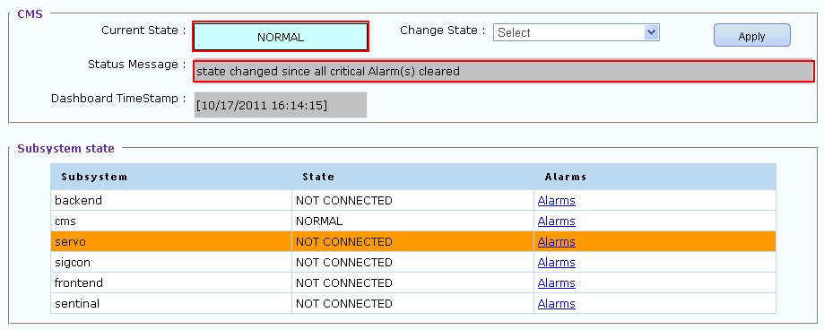

1. User can also clear multiple alarms at a time by selecting the checkboxes against corresponding alarms. Please see the image below for same –

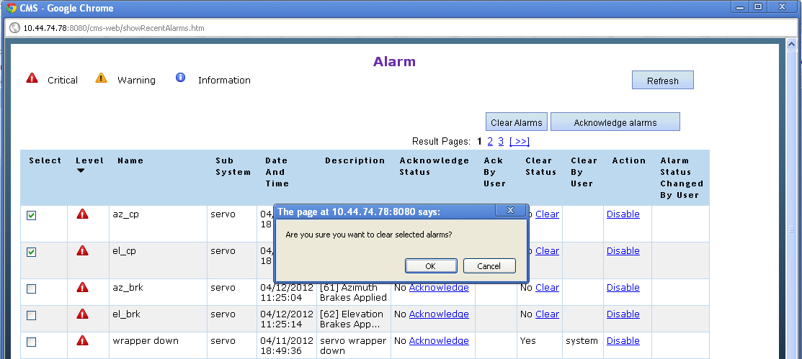

Note that if one of the selected alarms is already in cleared state then, system will show appropriate error message and would not clear any of alarm.

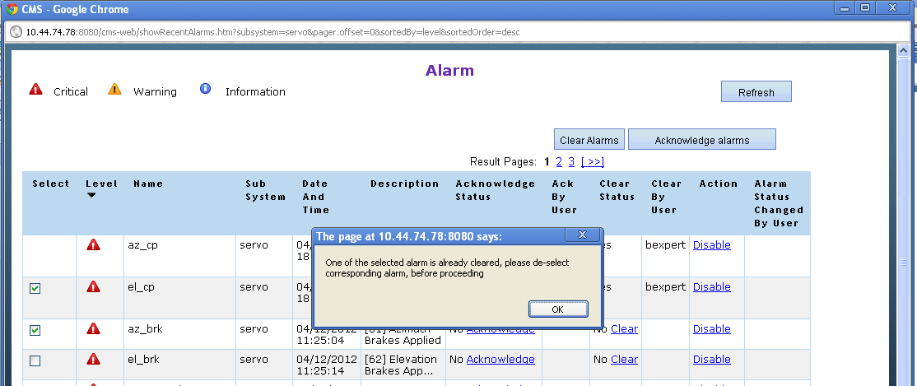

### Alarm Acknowledging

1. If user has appropriate permission to acknowledge the alarm then “Acknowledge Alarm” link or “Acknowledge Alarms” button will be visible to user.
2. When user clicks on Acknowledge link on the recent alarm page the alarm gets acknowledge and the user name of the user who acknowledged the alarm appears on the page.
3. Alternatively user can also acknowledge multiple alarms by selecting checkboxes against corresponding rows. Please see the image below for same –

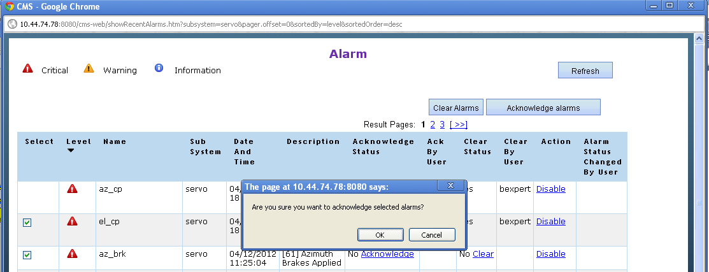

Note that if one of the selected alarms is already acknowledged then, system will show appropriate error message and would not acknowledge any of alarm.

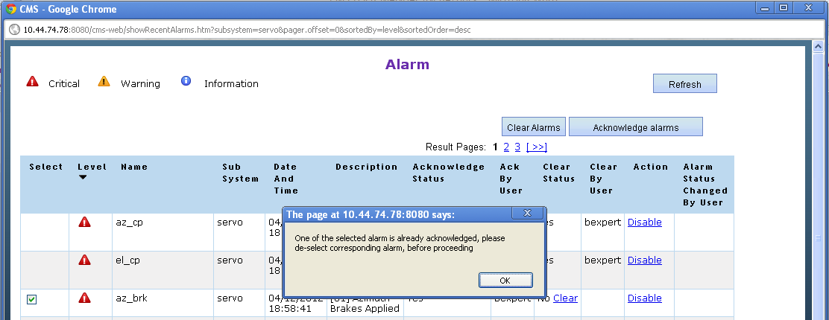

## Enabling-Disabling of Alarms

### Disabling of Alarm

* 1. User who has been granted the permission to enable-disable the alarm can only view the Action link. Other users can only view the current enable-disable status of alarm. To grant user the permission to enable-disable the alarm refer section 1.2.2.11.1 Add Role.
  2. By default all alarms are enabled. If user wants an alarm can be disabled. Once a particular alarm has been disabled next time if the same alarm arrives, then it won’t be raised till it is enabled again.
  3. Assuming user has been granted alarm enable-disable permission, when user disables an alarm it will ask for the confirmation, if user selects ok, the alarm gets disabled and the background color changes for the particular subsystem, and user name is updated in alarm status changed by user column.

For e.g. in below figure the critical level alarm wrapper down for frontend subsystem is being disabled.

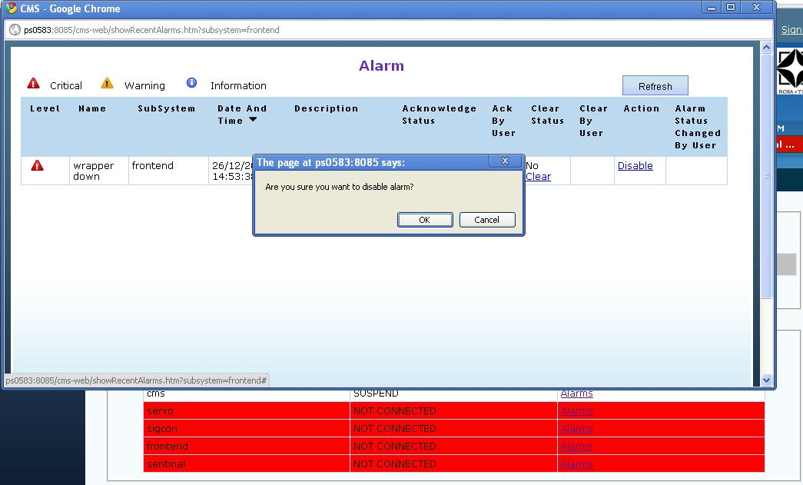

* 1. After disabling the alarm, the frontend alarm page and dashboard will look like as below. User can now enable the same alarm.

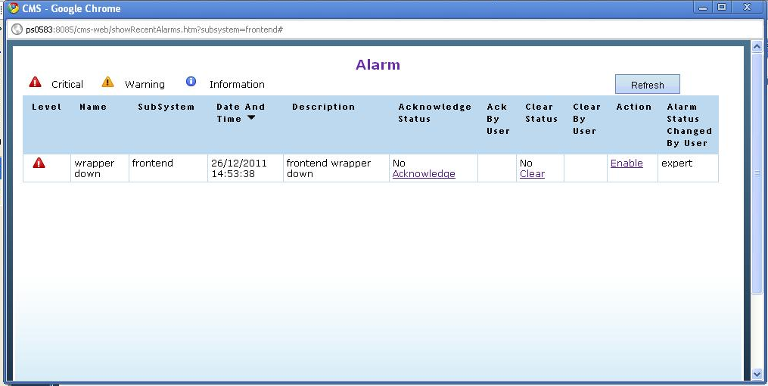

* 1. User can enable the alarm, by clicking on the Enable link. When user enables an alarm it will ask for the confirmation , if user selects ok, the alarm gets enabled and the background color changes for the particular subsystem, and user name is updated in alarm status changed by user column.

For e.g. in below figure the critical level alarm wrapper down for frontend subsystem is being enabled.

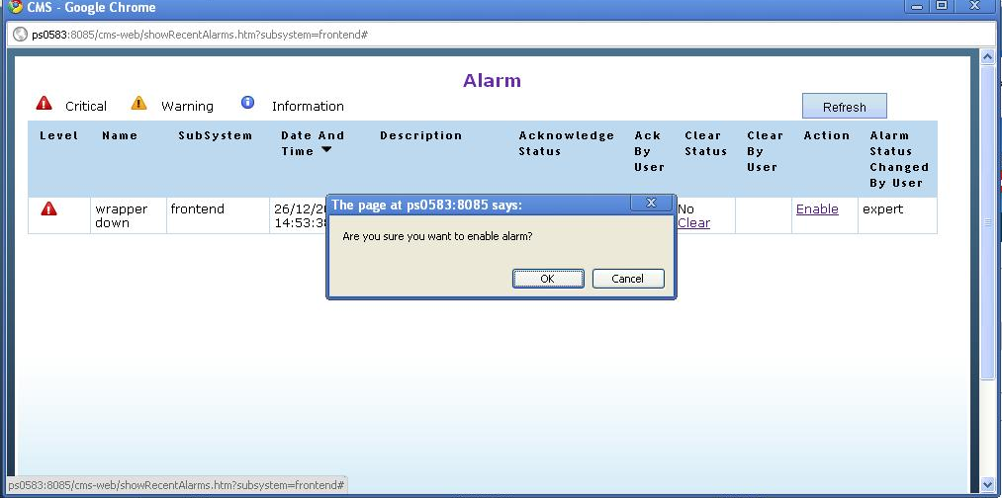

## Changing state in CMS

1. List of the CMS states are as displayed below:

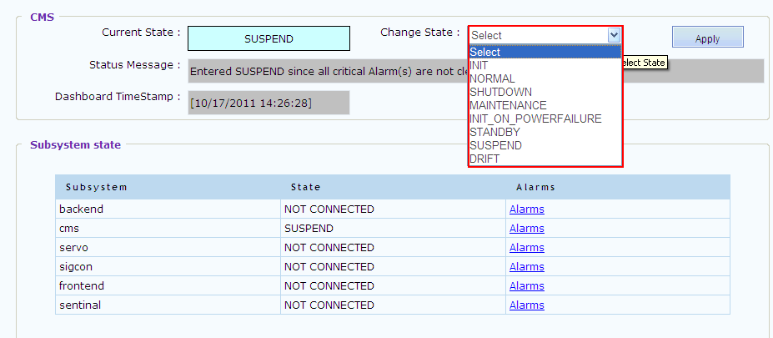

1. To change the state select the State and click on apply button. Then CMS will try to transition to the selected state, the following transitions are supported.

Transition_INIT_TO_NORMAL

Transition_INIT_TO_MAINTENANCE

Transition_INIT_TO_SHUTDOWN

Transition_INIT_TO_EXCEPTION

Transition_INIT_TO_SUSPEND

Transition_INIT_TO_STANDBY

Transition_INIT_ON_POWERFAILURE_TO_MAINTENANCE

Transition_INIT_ON_POWERFAILURE_TO_SHUTDOWN

Transition_INIT_ON_POWERFAILURE_TO_EXCEPTION

Transition_INIT_ON_POWERFAILURE_TO_NORMAL

Transition_INIT_ON_POWERFAILURE_TO_SUSPEND

Transition_INIT_ON_POWERFAILURE_TO_STANDBY

Transition_NORMAL_TO_SHUTDOWN

Transition_NORMAL_TO_MAINTENANCE

Transition_NORMAL_TO_EXCEPTION

Transition_NORMAL_TO_STANDBY

Transition_NORMAL_TO_SUSPEND

Transition_NORMAL_TO_DRIFT

Transition_NORMAL_TO_INIT

Transition_NORMAL_TO_INIT_ON_POWERFAILURE

Transition_MAINTENANCE_TO_SHUTDOWN

Transition_MAINTENANCE_TO_NORMAL

Transition_MAINTENANCE_TO_STANDBY

Transition_MAINTENANCE_TO_SUSPEND

Transition_MAINTENANCE_TO_EXCEPTION

Transition_MAINTENANCE_TO_DRIFT

Transition_MAINTENANCE_TO_INIT

Transition_MAINTENANCE_TO_INIT_ON_POWERFAILURE

Transition_EXCEPTION_TO_NORMAL

Transition_EXCEPTION_TO_SHUTDOWN

Transition_EXCEPTION_TO_SUSPEND

Transition_EXCEPTION_TO_STANDBY

Transition_EXCEPTION_TO_INIT

Transition_EXCEPTION_TO_INIT_ON_POWERFAILURE

Transition_EXCEPTION_TO_MAINTENANCE

Transition_EXCEPTION_TO_DRIFT

Transition_STANDBY_TO_NORMAL

Transition_STANDBY_TO_SHUTDOWN

Transition_STANDBY_TO_EXCEPTION

Transition_STANDBY_TO_SUSPEND

Transition_STANDBY_TO_INIT

Transition_STANDBY_TO_INIT_ON_POWERFAILURE

Transition_STANDBY_TO_MAINTENANCE

Transition_STANDBY_TO_DRIFT

Transition_SUSPEND_TO_NORMAL

Transition_SUSPEND_TO_SHUTDOWN

Transition_SUSPEND_TO_MAINTENANCE

Transition_SUSPEND_TO_EXCEPTION

Transition_SUSPEND_TO_INIT

Transition_SUSPEND_TO_INIT_ON_POWERFAILURE

Transition_SUSPEND_TO_DRIFT

Transition_SUSPEND_TO_STANDBY

Transition_DRIFT_TO_NORMAL

Transition_DRIFT_TO_SUSPEND

Transition_DRIFT_TO_EXCEPTION

Transition_DRIFT_TO_SHUTDOWN

Transition_DRIFT_TO_INIT

Transition_DRIFT_TO_INIT_ON_POWERFAILURE

Transition_DRIFT_TO_STANDBY

Transition_DRIFT_TO_MAINTENANCE

1. If CMS is moved to INIT or INIT_ON_POWERFAILURE state then CMS again executes the initialization script or restore script and raises the alarm as mention in State Machine Initialization section in case of initialization failure.
2. If CMS is moved to SHUTDOWN state the state-machine thread end and no other state-change happens. The tomcat server and active-mq server will also be shutdown. And for CMS and state-machine to be up an active-mq restart and tomcat restart will be required.

## Dashboard Status Message and Timestamp

The dashboard status message displays the reason for state-change.

The time stamp indicates the time at which cms changed its state from one to another.

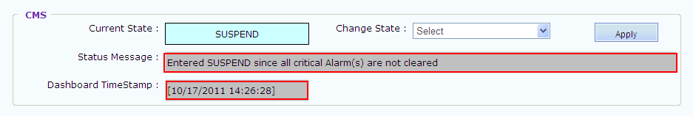

## Monitoring Parameter out of range Alarms

Monitoring Parameter out of range alarm would be raised whenever a monitoring parameter sent by wrapper goes out of range.

Alarms for various subsystems would be displayed in various colors depending upon the level of alarms raised for that particular subsystem.

Alarms that are configured for Monitoring Parameter out of range will only be raised. The alarm configuration is mentioned in the CMS Configuration and Deployment [NCRA] document. The alarm name and the monitoring parameter name should be same for the alarm to be raised.

For example: “**el_motor2_temp**” alarm would be raised whenever parameter reaches out of limit as shown below.

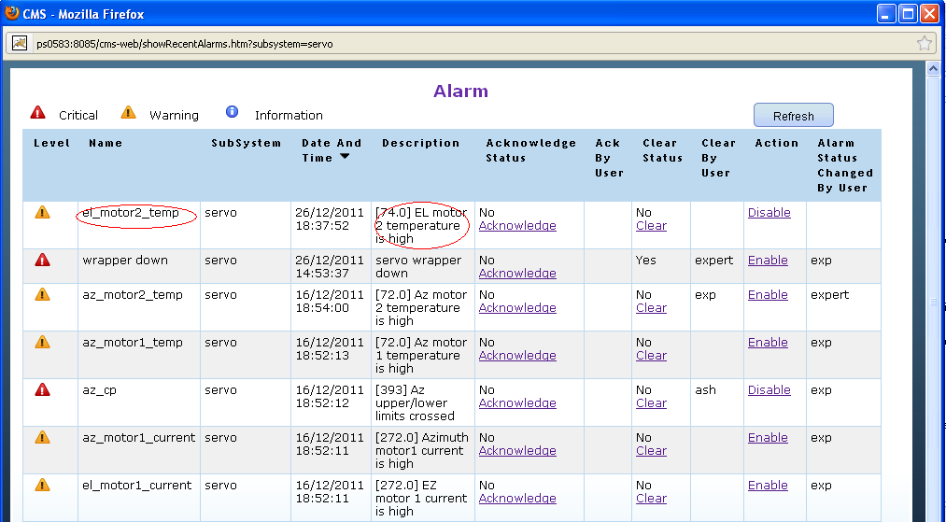

# Miscellaneous

## Pre-Observer Role

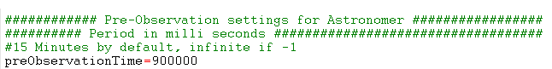

An astronomer/co-astronomer logs in to CMS in preObservation time as pre-observer.

**preObservationTime** before observation start time, allows astronomer to upload catalogs and validate his batch file in CMS. If “**-1”** then astronomer can login at any time to perform observation activities.

## Active Controller

The Astronomer/Co-astronomers users in CMS have some specific schedule of observation. These users are considered active during their particular schedule. CMS has a scheduler which runs after specific time interval. This Scheduler keeps track of schedules and when a schedule is active it displays the name of the Astronomer in Active Controller and the corresponding project code in Header.

The time interval after which scheduler will be invoked is configurable. It is specified in “observation_schedular_frequency” property in cms.properties. By default minimum time interval is 15 minutes. Any value specified below 15 minutes will be ignored by CMS and 15 min will be considered as scheduler frequency.

E.g.: The below figure displays the Active controller as “astro” since the current schedule belong to Astronomer whose username is “astro”.

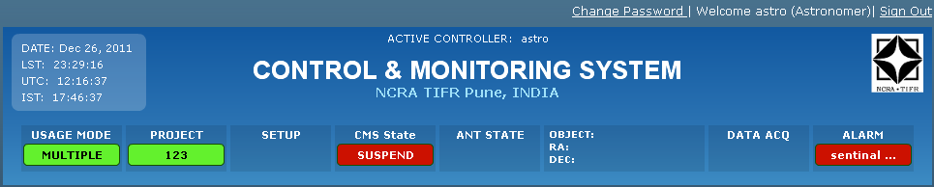

Whenever an active Astronomer/Co-astronomer logs in during their particular schedule, an alert message is displayed to that Astronomer/Co-astronomer showing the remaining observation time.

For E.g.: Below figure displays the time for which astronomers schedule will last, in this case it is 4 min 35 seconds.

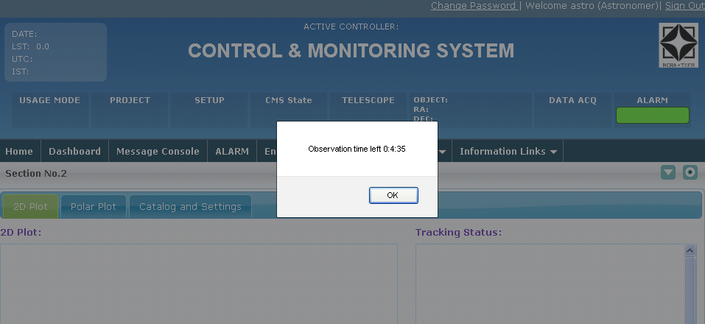

Astronomer/Co-astronomer will also be given a warning message showing the time left after which their observation will get over.

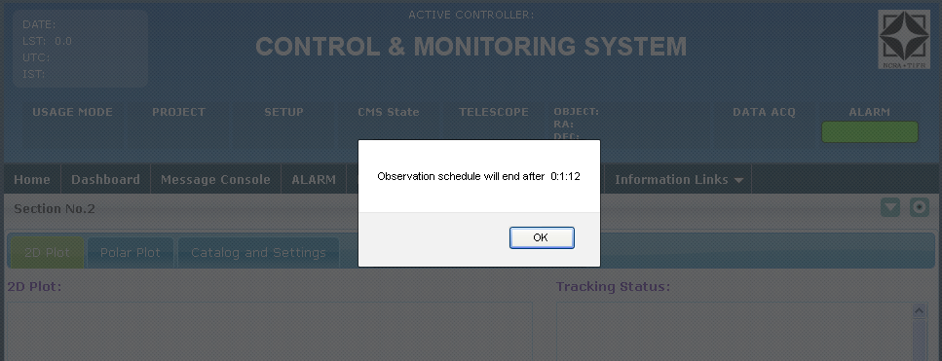

Once a particular schedule is over Active controller will display the name of next active astronomer/co-astronomer or will remain blank. Corresponding astronomer/Co-astronomer will also be logged out automatically once their schedule is over.

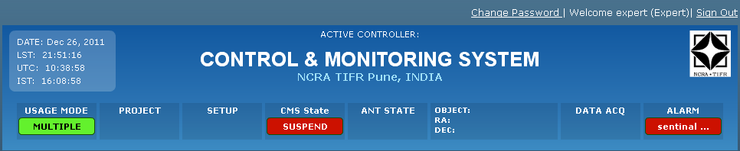

## Message Console Logs

All the data appearing on Message console is logged in **messageconsole.log** file. This file is generated in Tomcat log directory.

## Dashboard logs

The CMS state changed history is logged in **dashboardhistory.log** file. This file is generated in Tomcat log directory.

## Email Alerts

CMS supports following emails alerts

### User Registration

If a valid email address is supplied in while creating a user in CMS, then CMS sends registration email to corresponding user with preliminary login information.

### Critical Alarm Alert

When CMS receives a critical alarm from wrapper or CMS generates critical alarm due to system variables going critically out of range an email is sent out to an email alias configured in cms.properties (criticalalarmemailalias property) about critical alarm situation, so that corresponding users can trigger corrective action.